HCS Analyzer v1.2.9 (beta)

Let’s start with the *image accessor* capabilities. The number of pre-defined image accessor has increased and includes IN Cell, CV7000 etc.

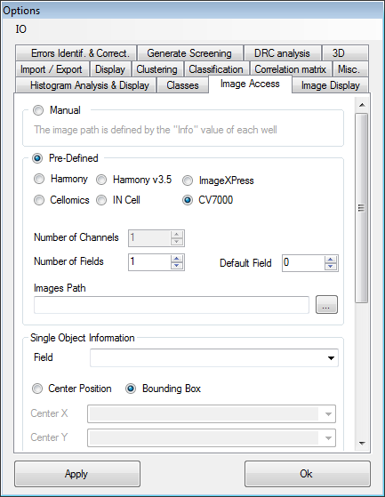

HCS Analyzer v1.2.7 (beta)

Once again we will start by a quick survey of the *single cell analysis* novelties*.*You will probably notice changes in its user interface. On the right side of the window there is now a tab box. *Log* and *graphics* are similar to the previous version, however there is a tab called *Selection* containing a list of check boxes. Those check boxes define the activated/dislplayed phenotypes: every process will be based on the current selection.

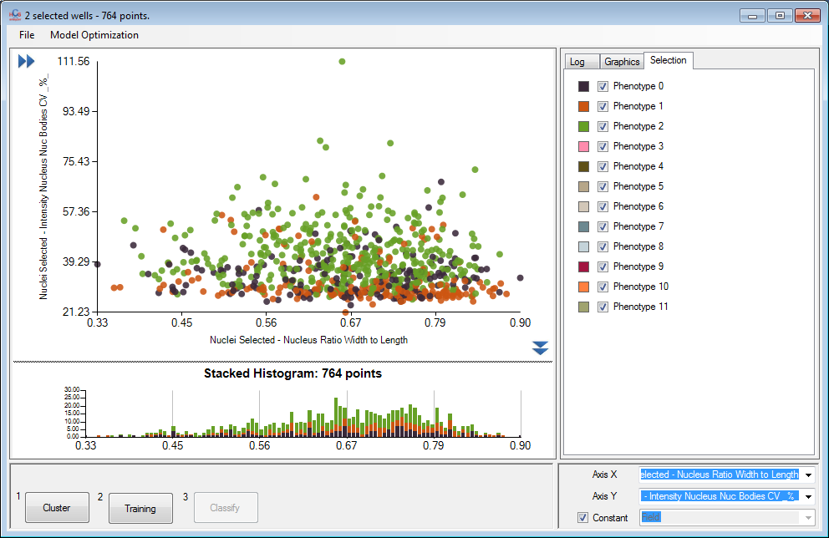

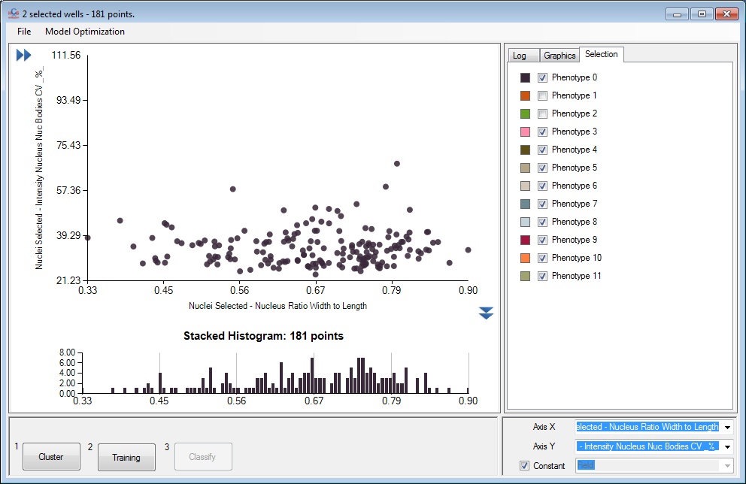

HCS Analyzer v1.2.6 (beta)

The best way to quickly summarize the few enhancements performed this summer is to give you a short tutorial about importing well-based data generated by an IN-Cell platform. The first new improvement is located in the *File* main menu and is named *Import Screen (directory).* This option gives you the opportunity to select CSV files located in a specific directory (particularly useful in our case where every plate got its own CSV file).

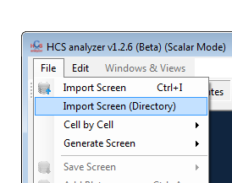

You will then reach the regular *Importer Options* control window. You will notice a novel *Well Position Mode* denoted by [A – 2]. This option is dedicated to the IN-Cell data format. Note that for this platform you will need to specify a header size of 1 as display below.

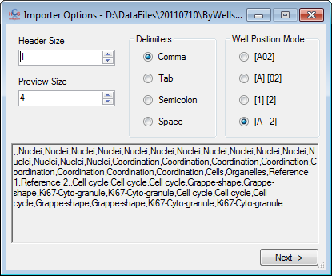

You will then have to select your features of interest. This drives us directly to the new option: you don’t have to specify a plate name.

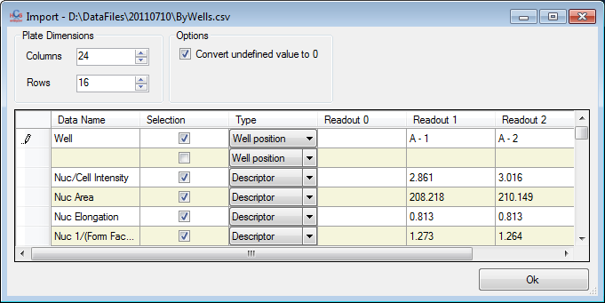

This is typically the case for the IN-Cell data where the plate name is defined by the containing directory. As a plate name is still mandatory for the application, you will the choice on the next menu: the plate name can be either defined by the parent folder or more directly by the file name.

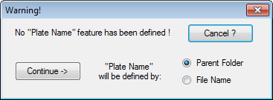

By clicking *continue->* the data will be eventually loaded. To conclude this short tutorial, you can link the images of the IN-Cell by selecting the proper imaging platform in the *Options->Image Access* menu.

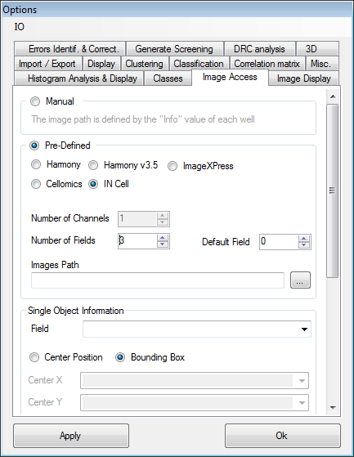

Let’s quickly conclude by few additional options. First you can now save the current plate property into a CSV file by right-clicking the display mode button and selecting the *Save Property* menu.

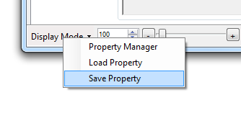

In the *Manual Hits Selection->Hits Class* window you can now activate or inactivate the rejected class. If the checkbox is not active then the non-hit classes will remain as they are.

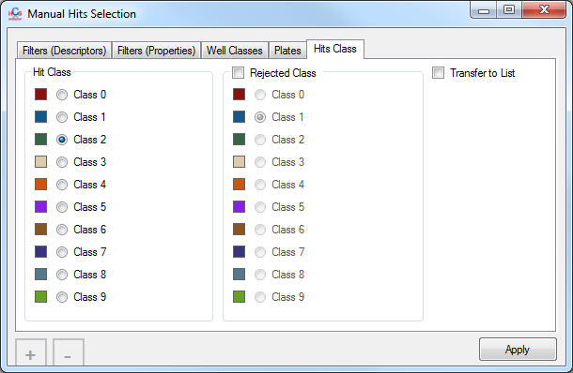

Finally, in the *descriptors filtering* menu: You can now perform the filtering on Single Cell or Average based descriptors by checking the associated check box:

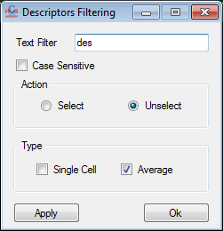

HCS Analyzer v1.2.5 (beta)

I finally took the time to transfer the systematic error detection into the new architecture (and this time it does not mess your current classes). You will find it in the *Quality Controls->Systematic Error Detection* menu.

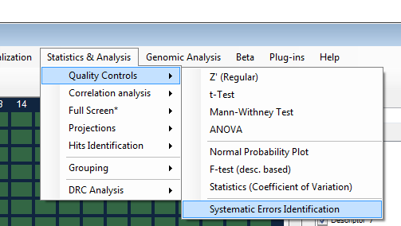

The first thing you will have to choose is a classifier. For a regular 384wells plate, a 4 classes K-means is a good option (this will probably be automated as well).

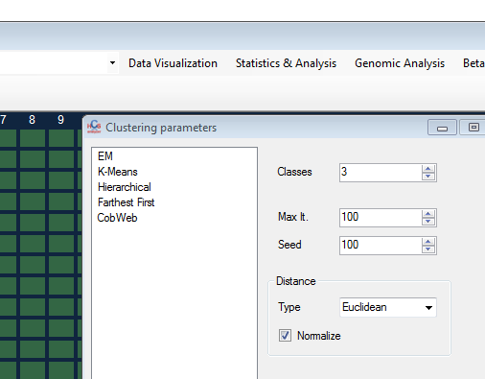

A window will then pop-up, summarizing the errors associated to each plate for each selected descriptor:

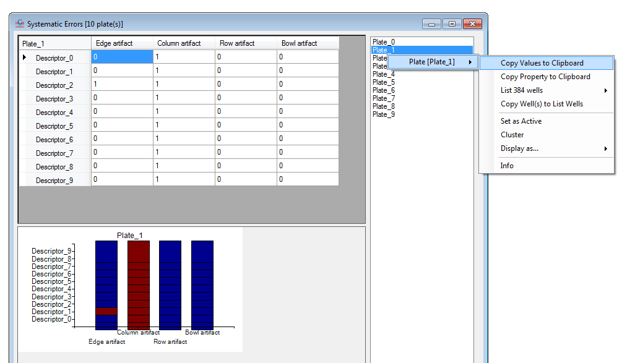

The Functions->Logistic classifier has been added.

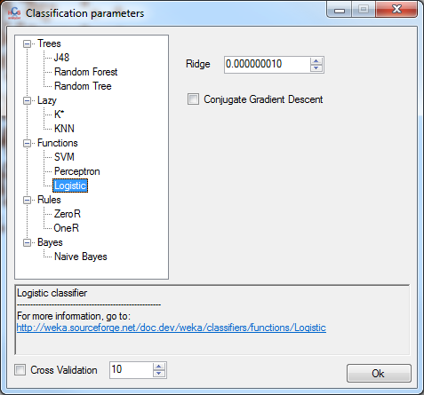

The histogram *bin number* option has been turned into a more complete option window. You can now define the bin size and the min/max to be used to build the histogram.

|  |  |
| --- | --- |
|  |  |

HCS Analyzer v1.2.4 (beta)

Here we are for a new update of HCS Analyzer… many things have change as you’ll see. Let’s start by the options menu. The first thing that you’ll notice (except the new design) is that the *Misc.* tab has been extended in order to display more information about the system but the libraries as well.

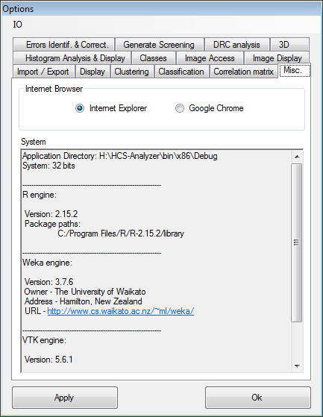

You can see on the top of the window a new IO menu:

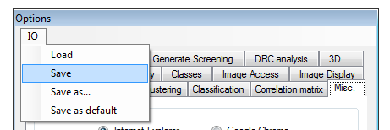

This gives you the opportunity to save the current options of the current session, including: the classes & phenotypes names and colours… what a relief! The file has .opt extension, and can be save as default if you want (in this case, the new environment will be loaded automatically at HCS analyzer first launch). If you want reset this, just simply delete the *default.opt* file in the application directory.

The image access information will also be saved in this file. So let’s talk about the *image access* new tab.

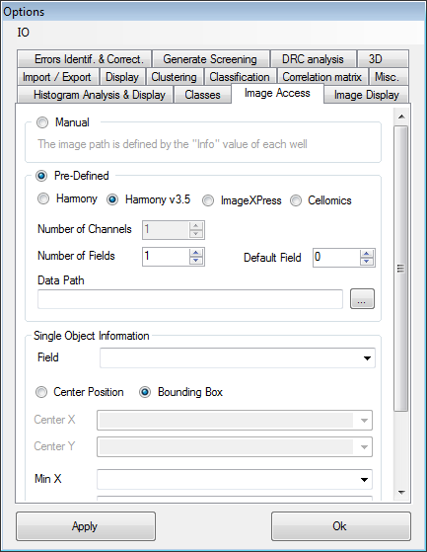

The image access purpose is to link the current screening to its associated **original** images.

Rem.: Currently HCS-Analyzer **does not** browse the instrument database.

Every imaging platform has its own way of naming and managing its images. Currently HCS-A is managing 4 of them:

* Harmony related platform (tested on Operetta, but every images processed through Harmony should work).

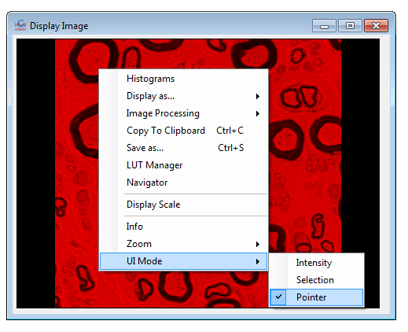

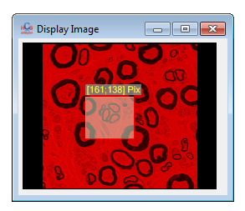

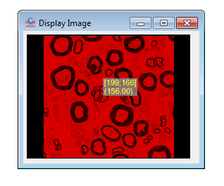

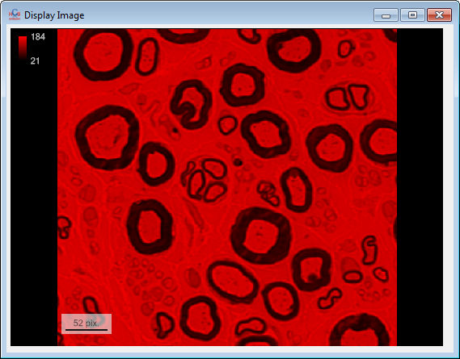

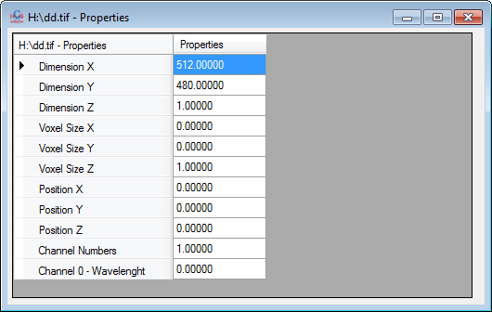

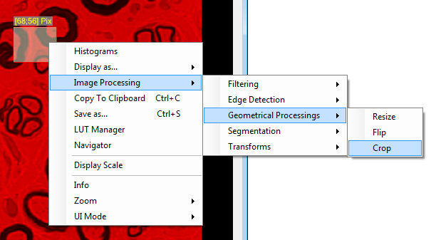

Another parameter for the image display has been added: *Opacity*. As you can guess its value define the transparency of the selected channel (0⬄ transparent).

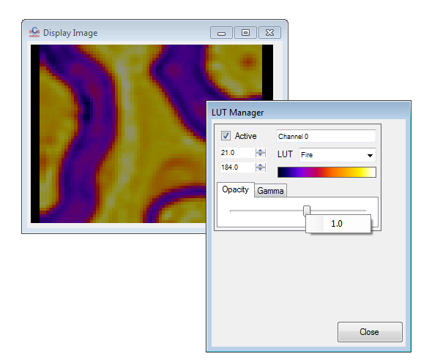

For convenience, all those properties can be stored in memory and then re-applied to another image (as long as it contains the same number of channels).

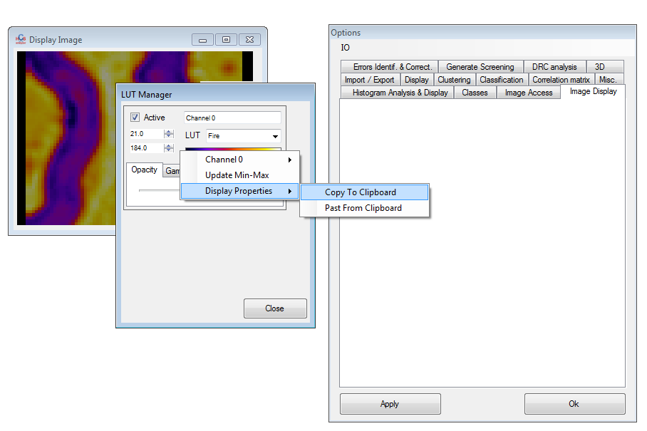

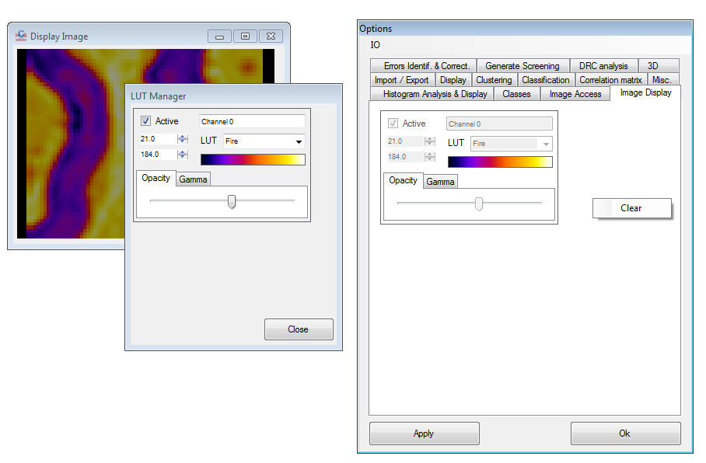

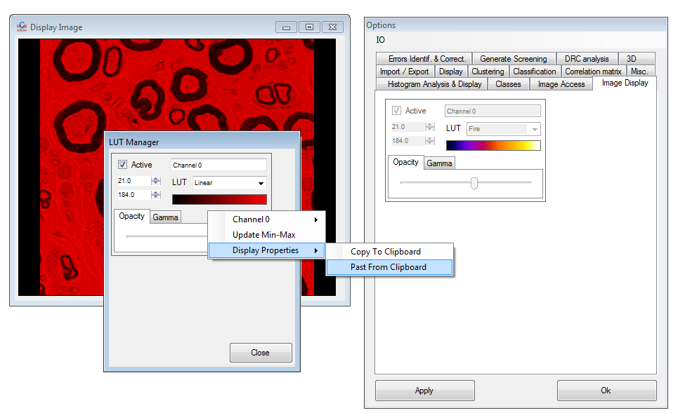

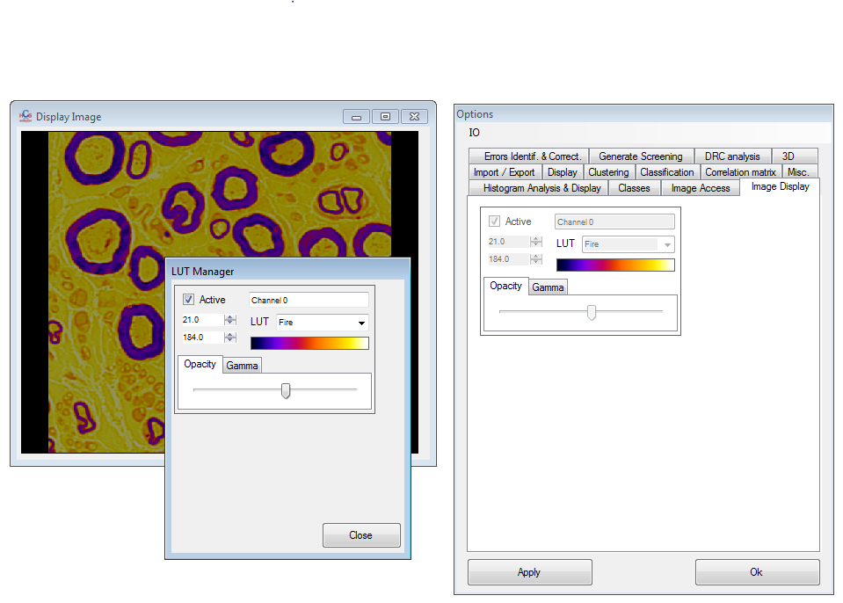

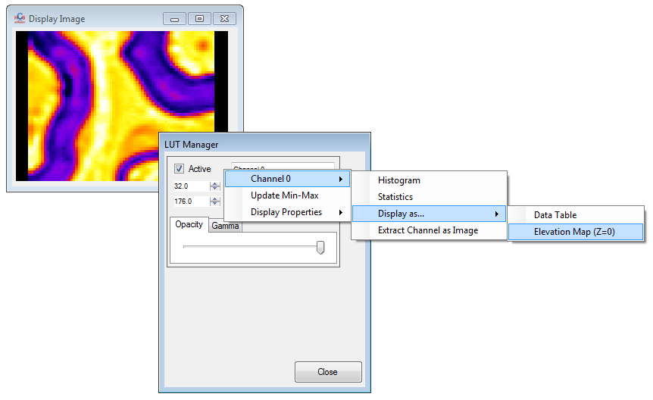

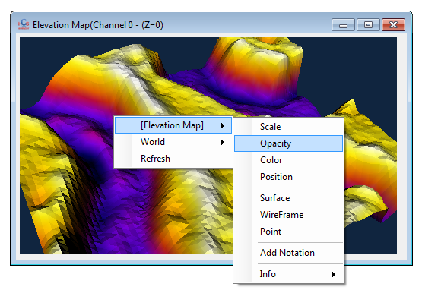

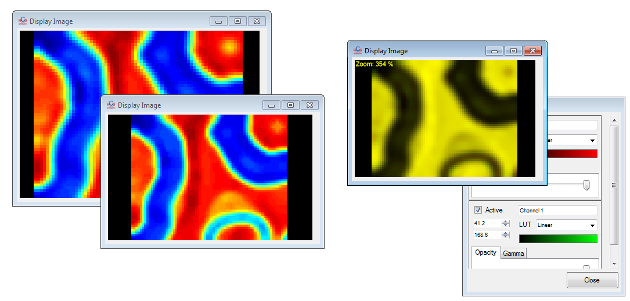

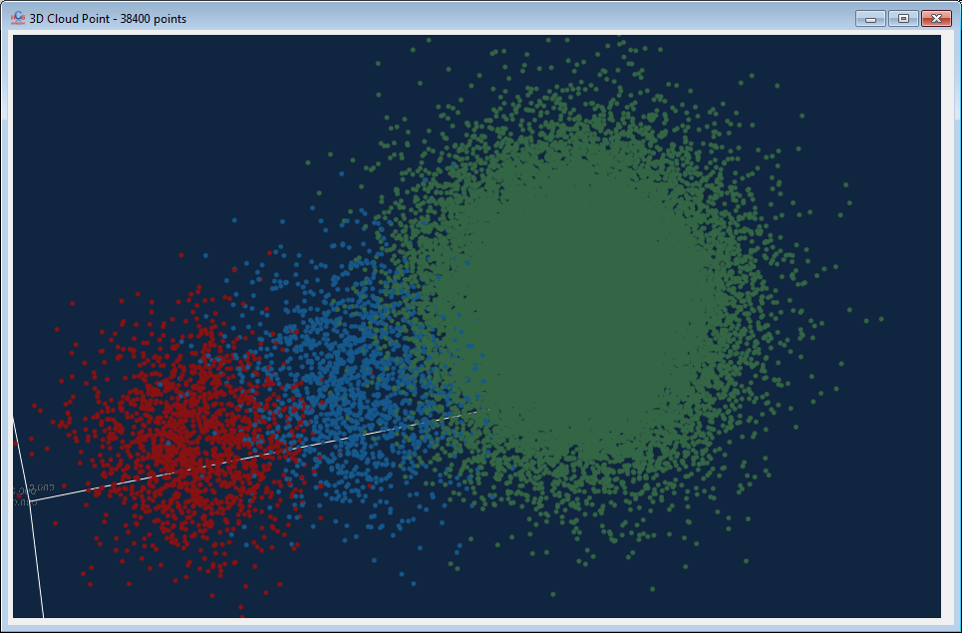

When you have to deal with large number of descriptors, the selection itself can be complex. You can now save the current status of the selection and re-apply it later (descriptor list context menu: *Selection->Copy Selection*).

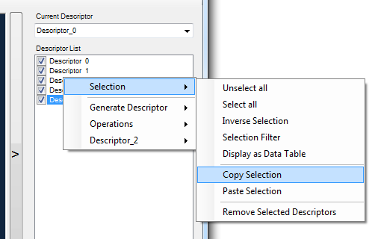

Little but convenient improvement of the directory browser control: you can now enter manually the folder directory in the bottom text box (useful when the directory is not browsable).

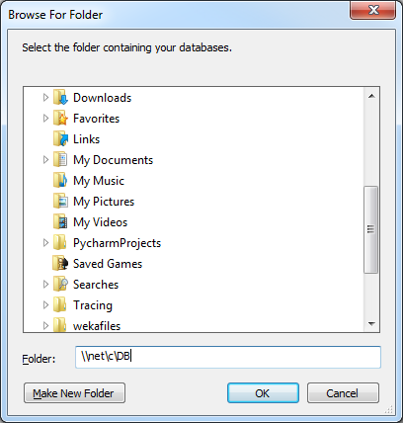

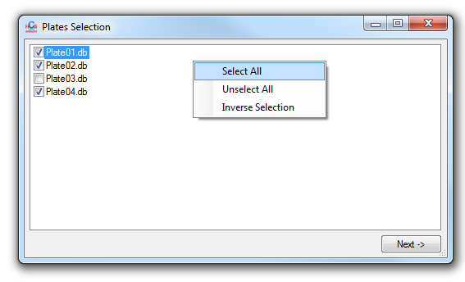

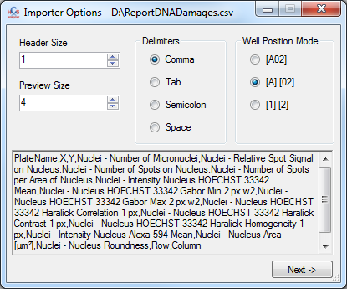

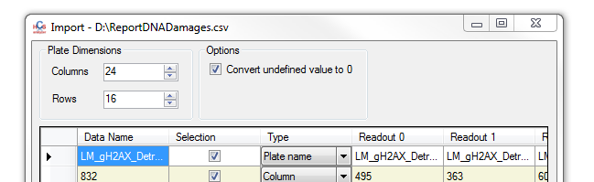

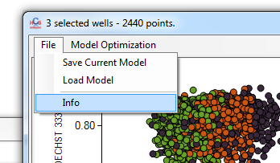

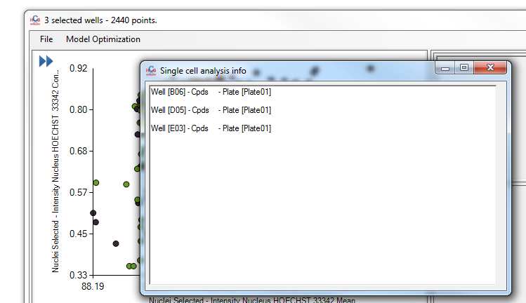

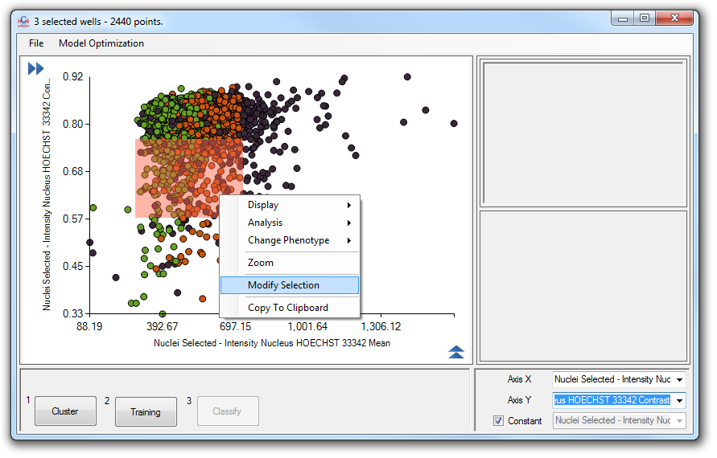

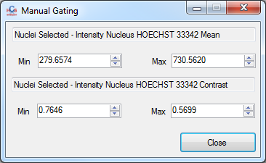

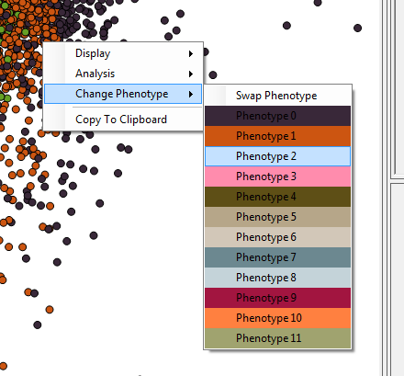

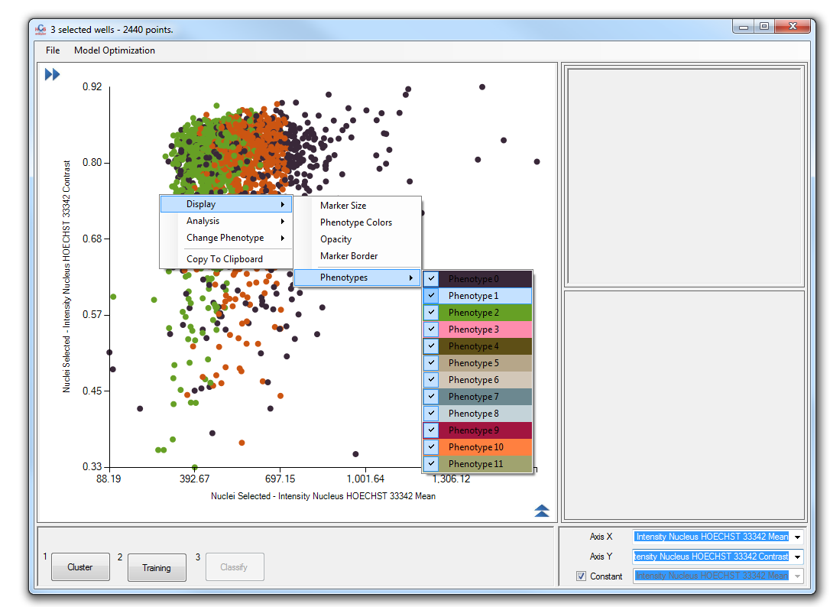

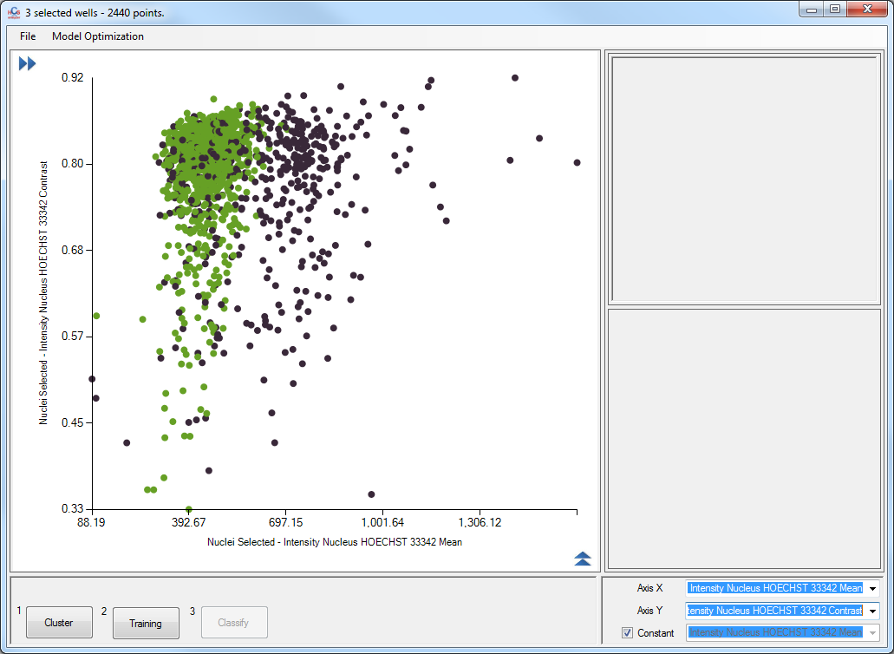

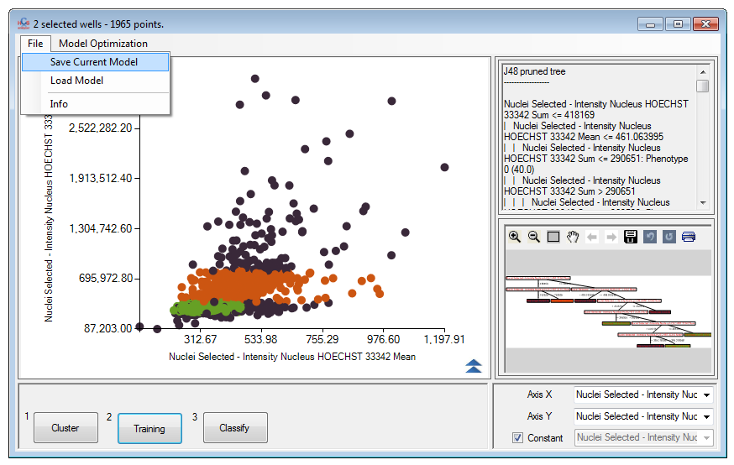

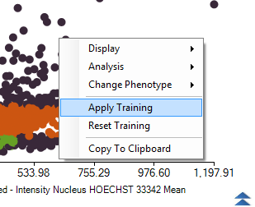

The Single Cell Operations has been slightly extended as well. You can now see a post processing group box. If active, the resulting value can be post processed using simple scalar mathematical operation.

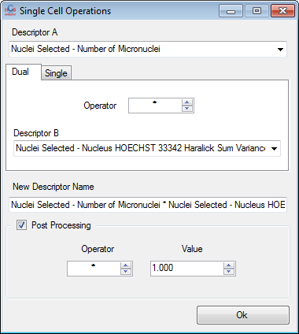

By right clicking on the *display property* menu you can now access the *Property Manager* context menu.

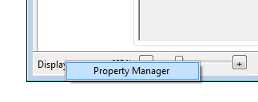

This control will display all the active properties (than can be used for combining or selecting well/plates etc…). Properties displayed in red are “locked” and thus cannot be removed.

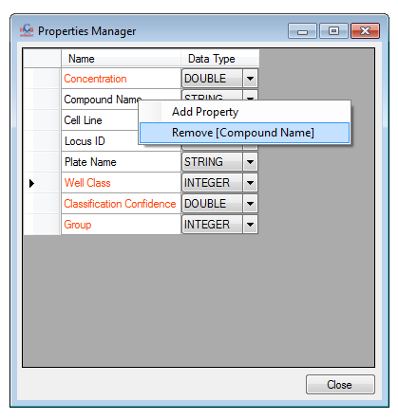

You can then remove the others by accessing the context menu associated to this property. You can also create a new property. You have to define its name and type, and for the scalar ones you can then defined its minimum and maximum values.

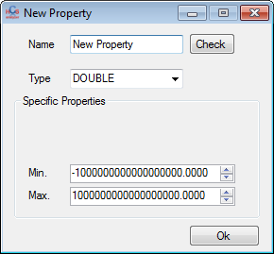

You can also convert the scalar properties to a descriptor

Rem.: In HCS-A a descriptor is a double type, every value that do not fit this scheme will then be converted to 0.

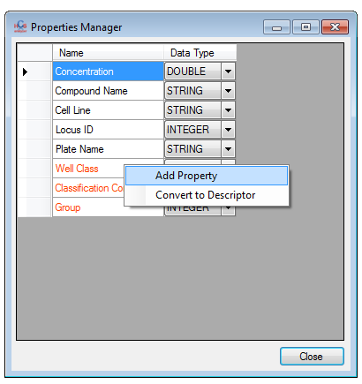

You can also now export single cell values as CSV file. This option is linked to *File->Cell by Cell* menu or every related *list of wells->Single Cell->Export DB as CSV* context menu as shown below:

|  |  |
| --- | --- |
|  |  |
|  |  |

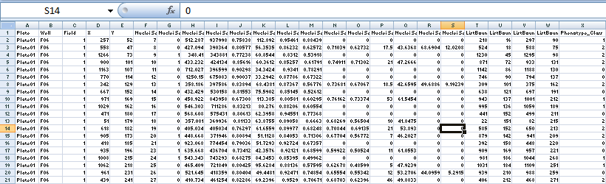

HCS Analyzer v1.2.3 (beta)

After summer break it is time for a brand new release of HCS-A with the v1.2.3. Let’s start smoothly with a few upgrades:

Descriptor *Single Cell Based Operations* has been extended:

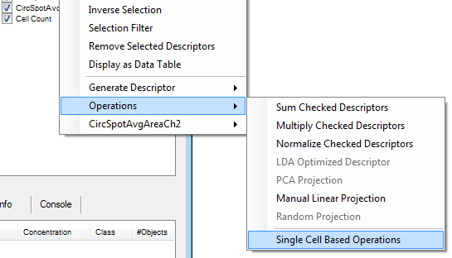

On top of the already available dual operators, a series of single operators has been added. You will find Log, Sqrt (both with restriction due to HCS-A data type), Abs and Exp… if you need more don’t hesitate to post a request.

|  |  |
| --- | --- |
|  |  |

The main user interface has been upgraded as well. The LUT context menu gives you the opportunity to turn on/off the colour associated to the average value. This could be particularly useful when working with the histogram mode view.

|  |  |
| --- | --- |
|  |  |

The LUT (Look Up Table) has been modified as well. You can now select the colour scheme within a list of common palette. Again, if you want favourite palette to be integrated, don’t hesitate to post a request.

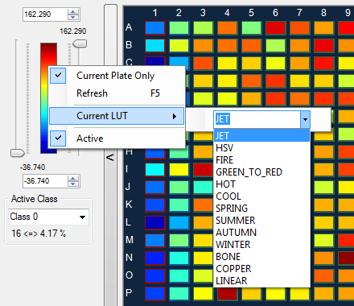

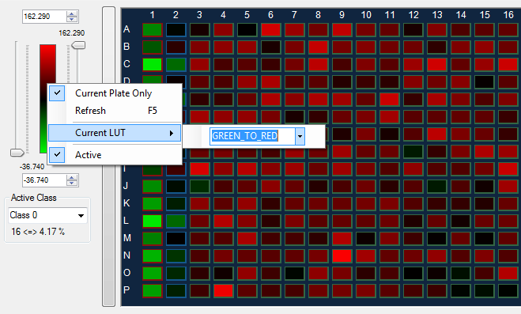

The palette display is now dynamic, following the user high and low threshold:

|  |  |
| --- | --- |
|  |  |

From another perspective, you can now access the entire screen as a list of wells (be careful the data hurdle can be important).

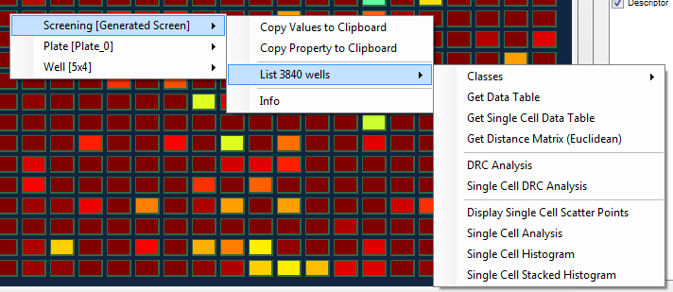

Taking benefit of the new core, I added a few functionalities in the Data Table Viewer such as *Clustering* (accessible as usual using the context menu *Operations->Clustering*).

|  |  |
| --- | --- |
|  |  |

This process generates another table with an extra column containing the newly created Class ID:

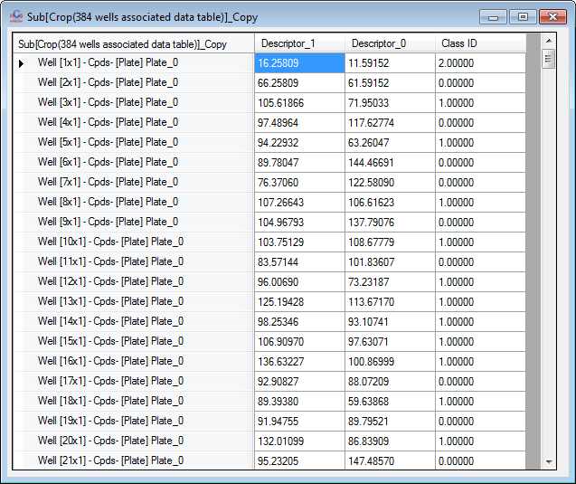

You can access information about this clustering (or any other information), using the column Class ID *Info* context menu:

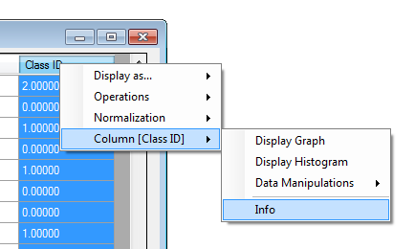

A text window containing the associated information will then pop-up.

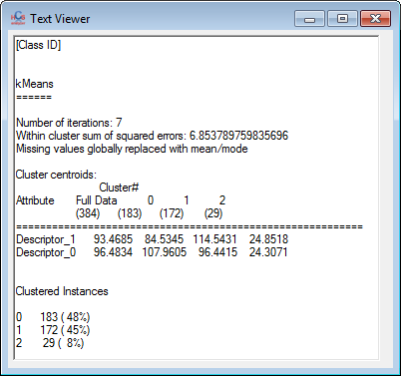

A simple feature has been added to the 1D scatter graph: the corresponding histogram is now directly visible below the graph:

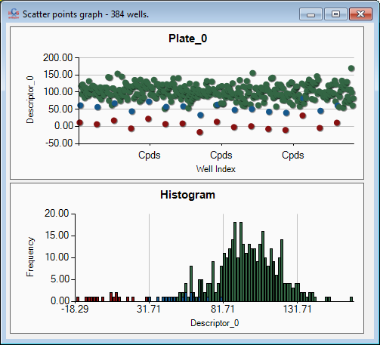

A useful feature called *Inverse Selection* has been added in the Descriptor List context menu.

|  |  |
| --- | --- |
|  |  |

Finally it is time for me to introduce the new 3D engine that will replace the previous one bringing many new functionalities and much more consistent with the new HCS-A core. To have an overview of the 3D engine, let’s look at it through the *3D Scatter Plot* viewer. They are many different way to use it, but we will use the *Data Table Viewer*: If 3D columns are selected, you can access the *Display As->3D Scatter Graph:*

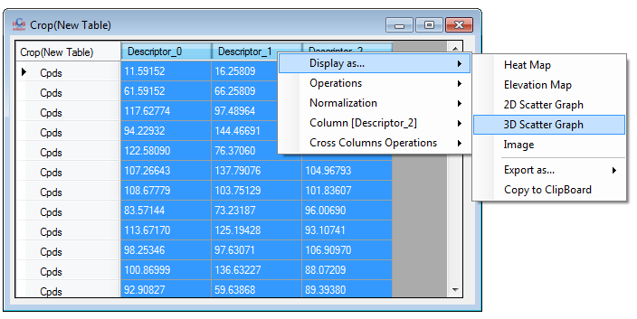

A menu will then popup, giving you the opportunity the set up some options.

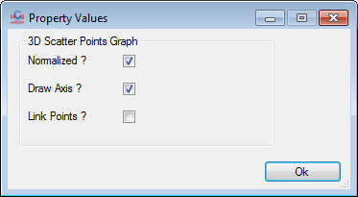

Then the 3D display will appear:

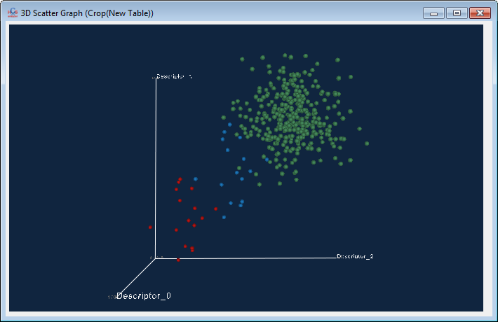

Let’s have a quick look at the functionalities available through the contextual menu. This menu will depend of the clicked object.

The basic one is accessible from everywhere, even if no object is clicked:

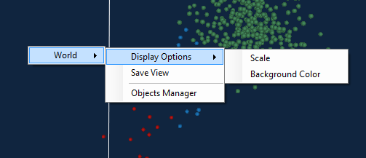

You can also access the object associated menu if available. Typically if a sphere is linked to a Well you should be able to access all the well related menus, including as usual the entire hierarchy (Well->Plate->Screening menus):

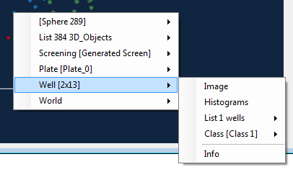

Each individual 3D object contains its own context menu independently to any potential linked object.

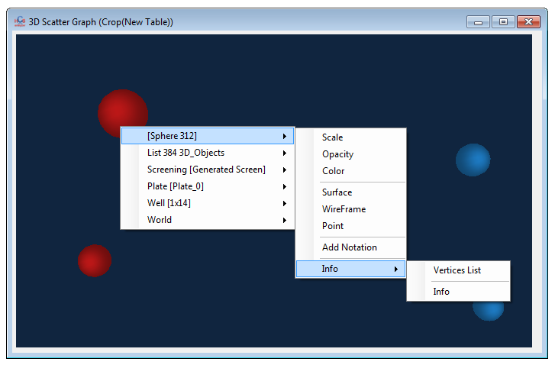

For most of the 3D object many display properties can be updated, like the colour, opacity etc…

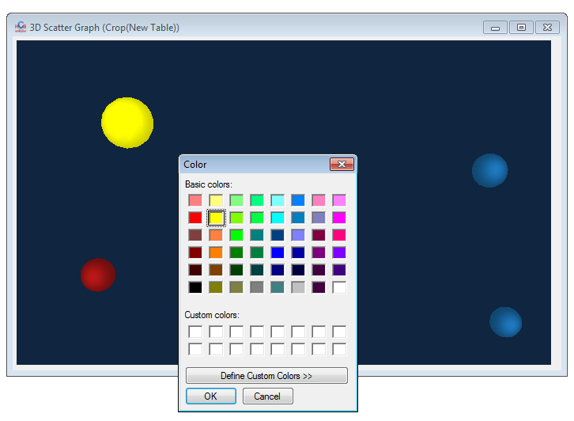

You extract the vertices list of the selected object as well:

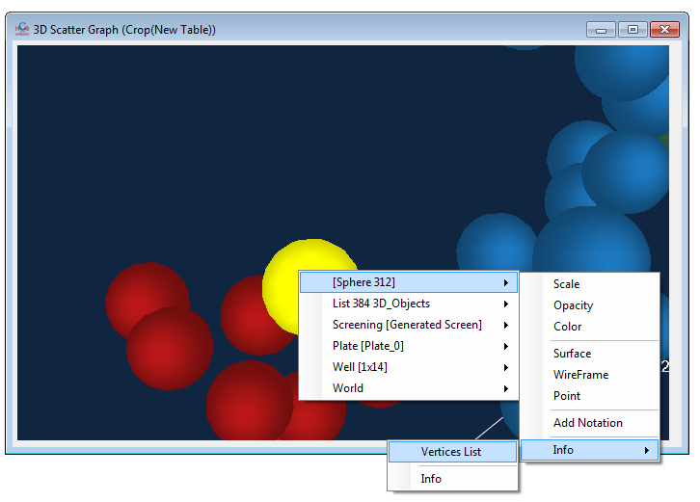

And do whatever you want with it, such as a 2D scatter point display (not really useful here).

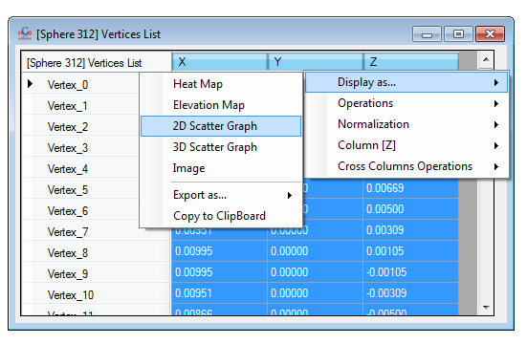

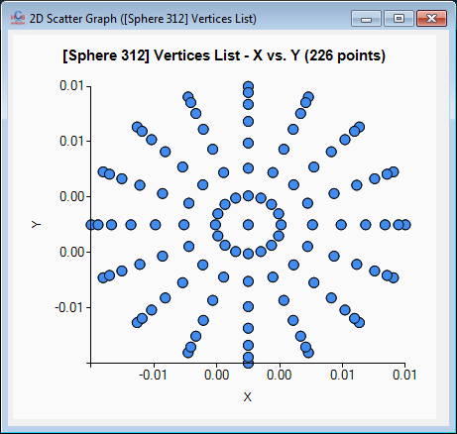

Moreover, 3D objects can be merged together creating a “super” object, also titled *List*. If this is the case, the context menu will contain an extra menu related to the super object (here called List 384 3D_Objects):

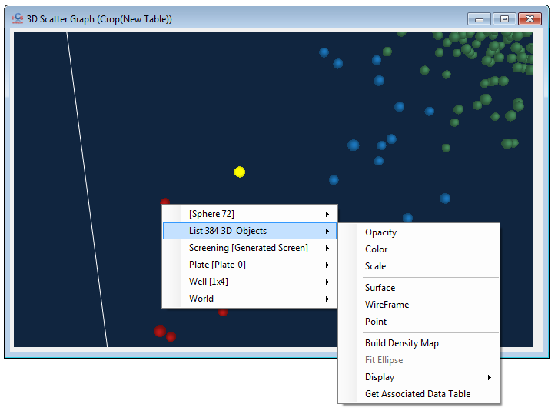

Many properties similar to single individual 3D object would be available. When a property is updated at this level it affects every contained object.

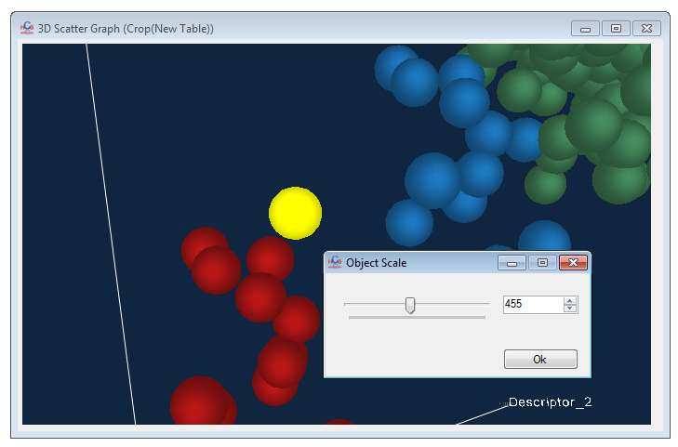

Some options are specific to this kind of super objects, such as Delaunay Triangulation, 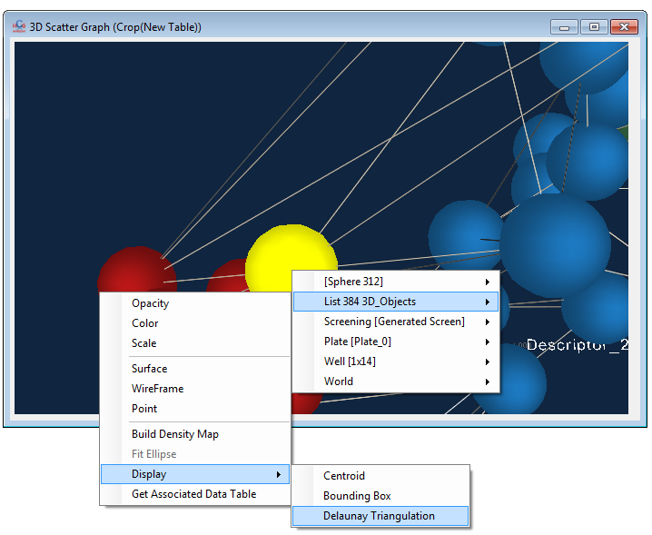

Or bounding box etc…

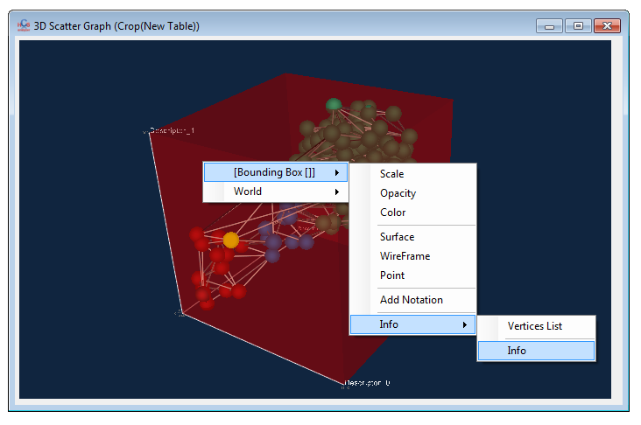

The generated object becomes an accessible object by itself. A density map can be created as well, generating a 3D volume rendering:

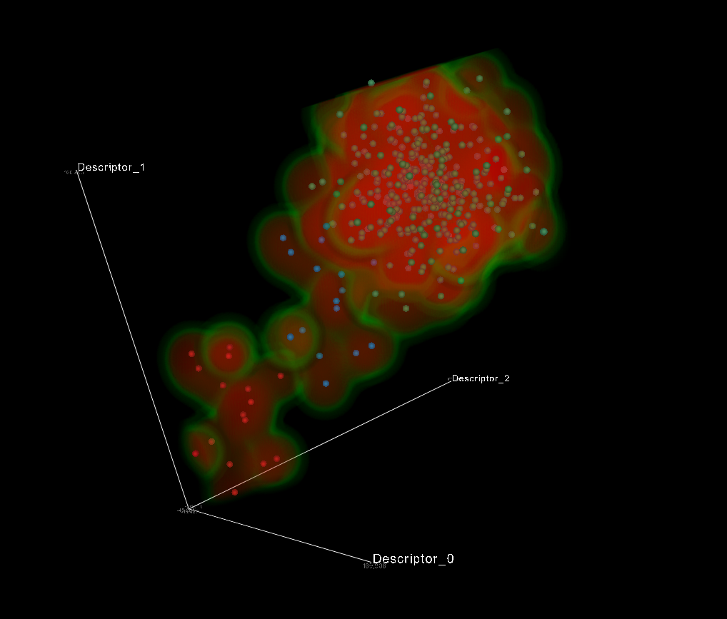

You can also access the 3D scatter plot from any Well List context menu:

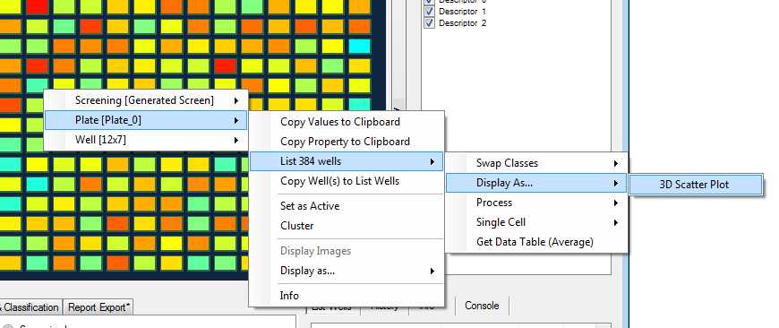

In this case, the property window let you choose the axis associated descriptors:

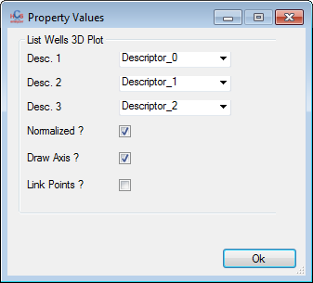

In this case you’ll notice that each descriptor is directly associated to each axis allowing you to access the associated options trough the axis context menu:

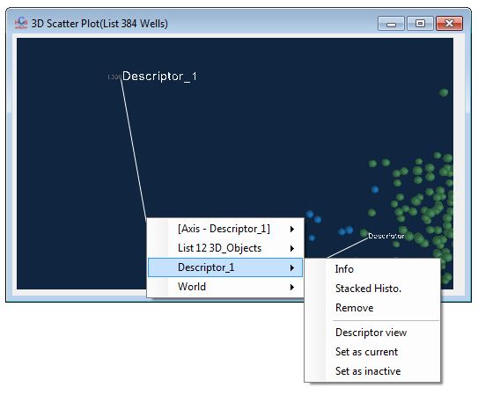

Many other features are available so don’t hesitate to play with the menus and explore the possibilities.

Finally, a data table can now be exported as an HTML file.

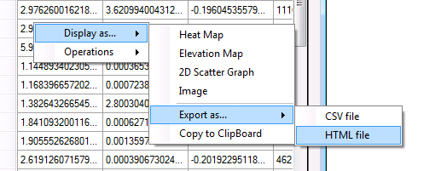

If this is performed from the DRC based table, the HTML file will include the DRC curves as well.

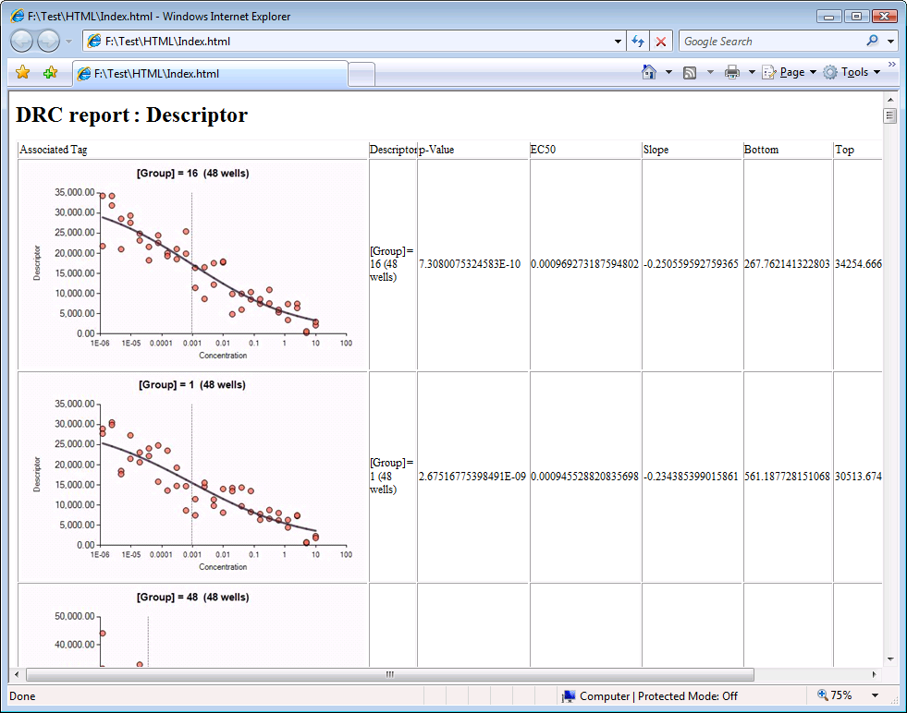

HCS Analyzer v1.2.2 (beta)

The first thing that you’ll probably notice on this new version is a new bar at the bottom of the user interface. At the very left of it, you can see now a *Display Mode* menu:

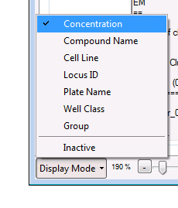

This menu contains a list of properties (a generalization of what was already implemented in HCSA). By selecting one of them, their associated values will be displayed on top of each well. If no value is available, then ”n.a.” will be displayed instead.

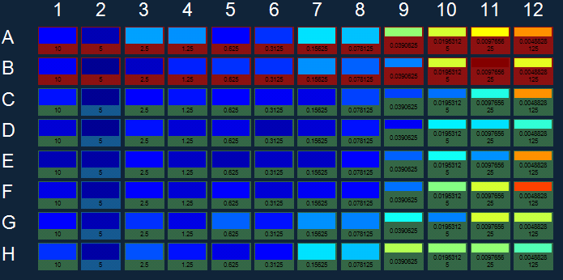

Those properties can be almost any kind of data (usually double, string, Boolean, etc.). You can copy those values to the clipboard by accessing either the Screening context menu or the Plate context menu:

|  |  |
| --- | --- |
|  |  |

When you are saving your screening as a CSV, those values can also be exported.

|  |  |
| --- | --- |
|  |  |

|  |  |
| --- | --- |
|  |  |

Those properties will be useful for the *Well Merging* option as we’ll see later.

At the right side of this menu you will find a novel Zoom control. There is actually not too many to say about it as it is quite intuitive.

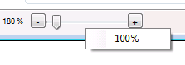

Another Designer component has been added in order to display more efficiently large number of panels. The panel is located on the left, and you can select your data of interest using the list box on the right of the control:

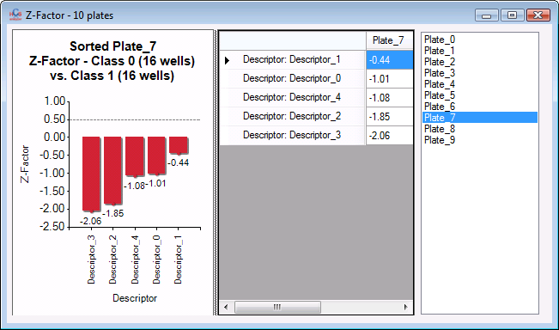

A novel and much more flexible manual hits selection has been developed. You can find it by clicking on

*Statistics & Analysis->Hits Identification->Manual Hits Selection*.

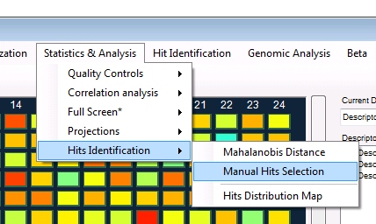

Let me describe the plug-in. In the first tab page, you can add (or remove) filters by clicking on the + button at the bottom left of the window. On the filter panel, select first the descriptor on which the filter will be applied, then type of values (Raw or Z-scored), then the type of comparison (<, >, <=, >=, =, !=) and finally the value on which the comparison operator will be applied to.

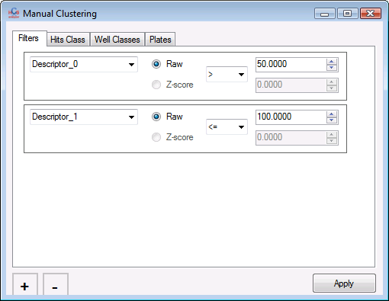

You can add as many filter as you want, and they will be processed sequentially. The Hits Class tab gives you the opportunity to define the new classes (hit and non-hit).

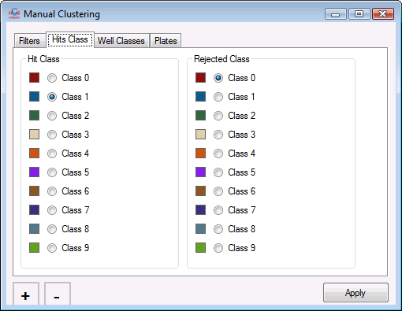

Finally, the two remaining tabs (*Well Classes* and *Plates*) allow you to specifically specify a subset of plates and wells on which the operation will be applied.

When one is performing a single cell analysis, a first window will give the user the opportunity to process only a sub-population of objects.

|  |  |  |
| --- | --- | --- |
|  |  |  |
|  |
|  |

Now let’s talk about a novel and hopefully powerful feature of HCS-Analyzer: the *Wells Merging*.

The aim of well merging is to provide an intuitive way of managing higher level structures like: Dose Response Curves (DRC) or Replicates. Let’s try to define what makes those features similar: a DRC is build on a set of wells (that can be located anywhere within the screening) clustered by a specific feature (or set of features) with different concentrations. It is a little like trying to manage replicates: wells are gathered based on a common feature (i.e.: replicate of wells should have the same compound name, same concentration and same cell line). What is required then is a tool to build quickly and efficiently clusters (or lists) of wells.

You will find this tool in *Statistics & Analysis->Grouping->Wells Merging Tool*

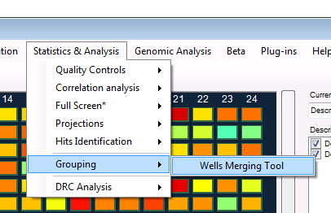

Then a window will appear, displaying a list of check boxes associated to properties (this list will evolve in the future versions of HCS-A and eventually would be defined by the user):

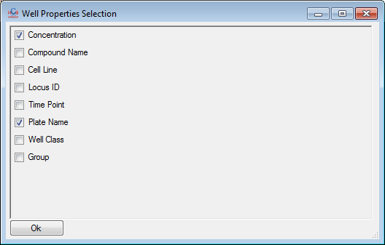

For every parameter checked, wells will be grouped when they display similar values. In the following example, wells will be grouped (1) by concentration and by (2) plate:

In this specific example, we had 10 plates and 24 points DRC per plate, so 10*24=240 groups of wells:

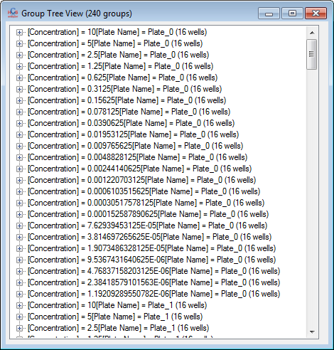

Rem.: by right clicking on a well, and then click on *info* from the associated context menu, you will see that this well has a group value associated:

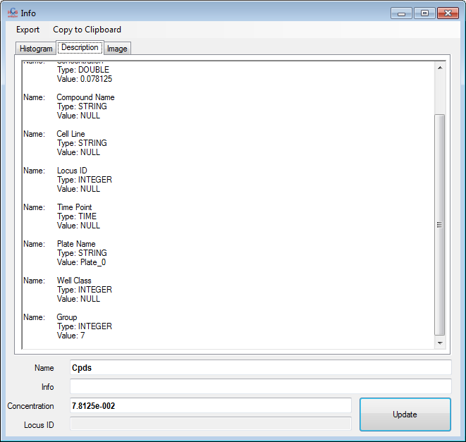

Everything single group has a unique *group* ID, which is itself a feature.

Coming back to the *group tree view* window, every group can be expanded, revealing the associated list of well. As a group is inherited from a *List Wells*, the context menu associated to the nodes give you access to all the regular *List Wells* properties:

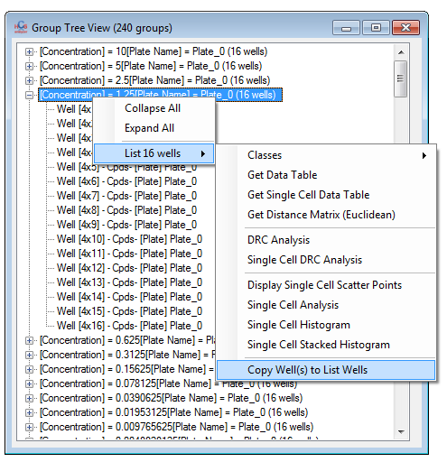

You can then, by example, copy this set of wells to the list *List Wells,* and perform all the regular associated treatments.

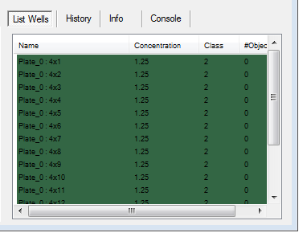

A right click on every single well from the list will give access the well associated context menu as usual:

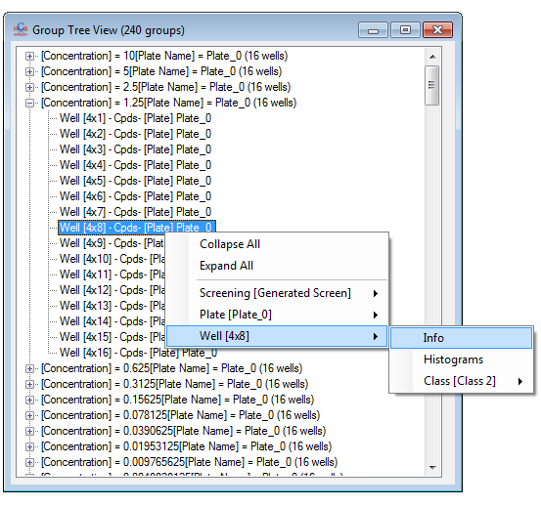

An easy way to see the groups is to simply group the wells by their group IDs:

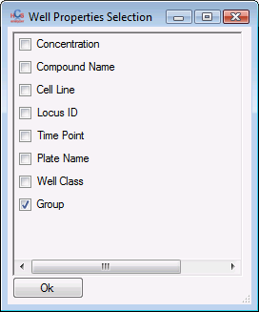

One of the aims of this approach is to provide a simple way to process and display large number of DRCs. HCS-A provides a user friendly tools to define group and concentrations of simple dispensed plates (but you can load the concentration feature as usual). Click on the *Statistics & Analysis -> DRC Analysis -> DRC Designer* menu:

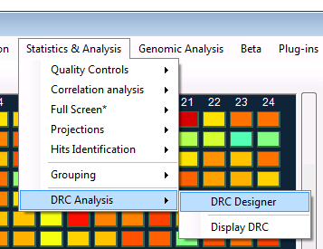

A window similar to the one below will appear:

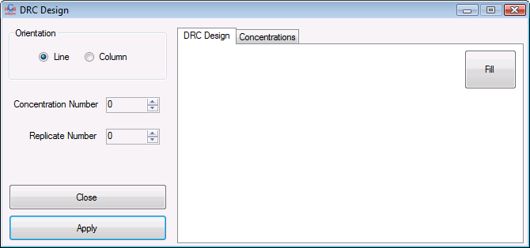

As long as this window is visible the main mouse wells selection is overridden. It means that by selecting group of well you will define regions where the DRCs (replicated or not) are located. Here is an example:

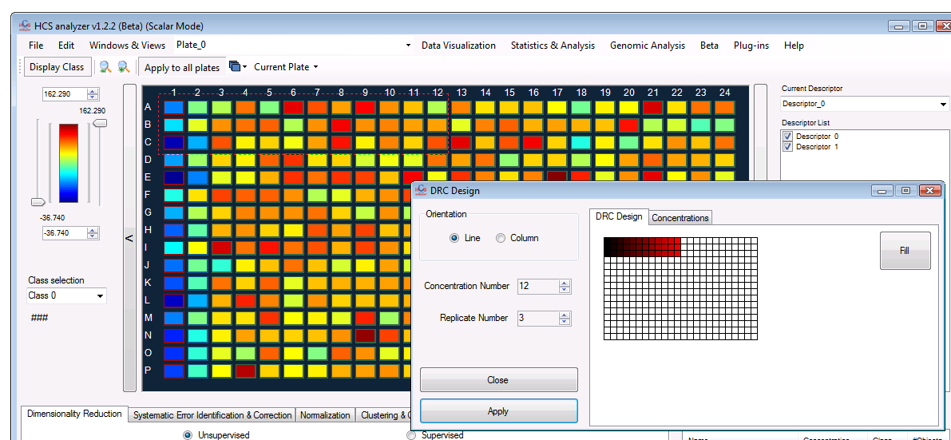

The fill button gives you a representation of how the current selection will be extended and applied (rem.: this function has just been integrated for display purpose and does not change anything to the further processes).

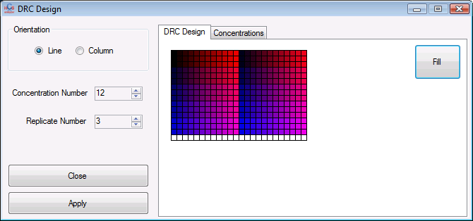

You can then move to the next tab to define the concentration values.

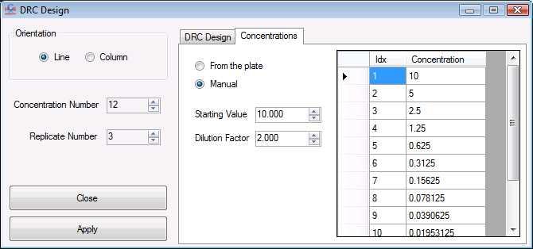

This tool provides a simple way to define concentrations, but this can be done by loading data from a .csv file.

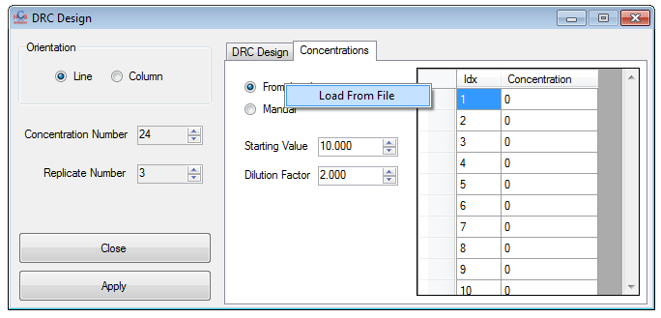

Once done press *Apply*, and the following window will popup, requesting a list of plates to apply the operation. You will see at the bottom right of the window a check box *Update Group ID .*If this box is checked then the group ID defined previously will be changed regarding the specified design.

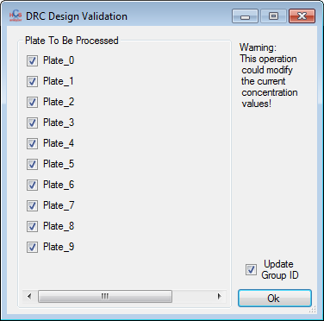

If now, I check the group values by doing this:

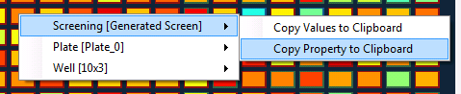

then:

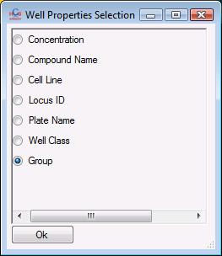

And finally paste it into another software:

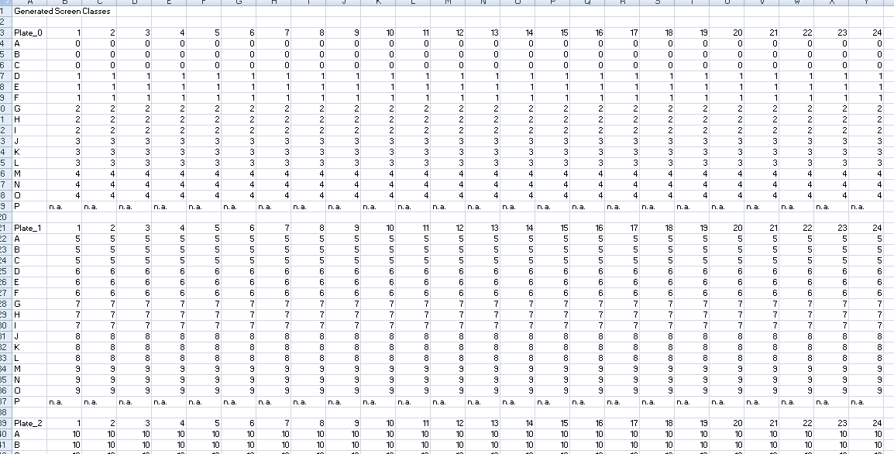

The result is similar to the design operated before. I can also assess the group associations by selecting:

*Statistics & Analysis->Grouping->Wells Merging Tool,* with only the *group* selected:

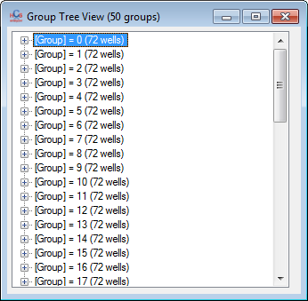

In this case, similar group IDs are located within the same plate, but there is no absolute restriction which is convenient for the replicates analysis as we’ll see later.

We can of course now directly display the DRCs associated to every single list of wells as follow:

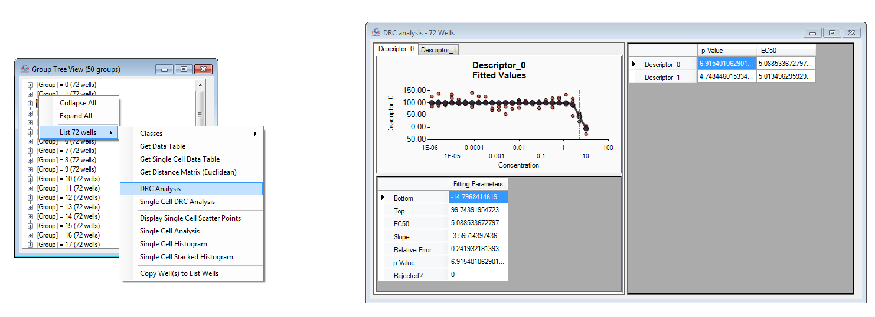

But also display all the DRCs from the current descriptor by using the *DRC Analysis* menu from the *Group Tree View* context menu:

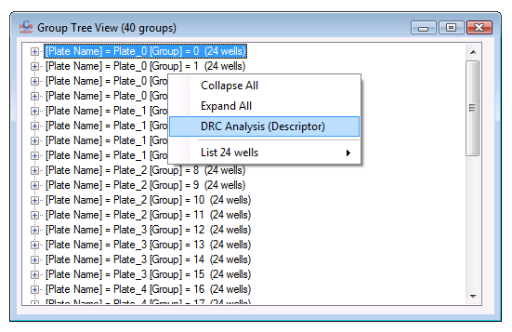

A window will then appear split in two: on the left you have access to each individual DRC, sorted in the same way as they are displayed in the *Group tree View*. On the right panel, you’ll find a table summarizing the information related to every DRC. The table is by default sorted by the p-value, which is supposed to give you a DRC quality. In the following example, the best (i.e. lowest p-value) is given by:

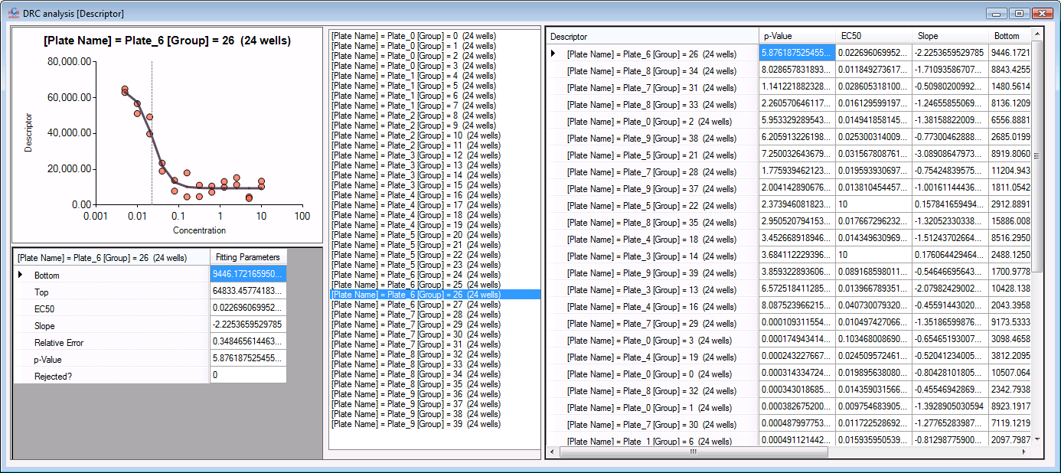

When the worst is:

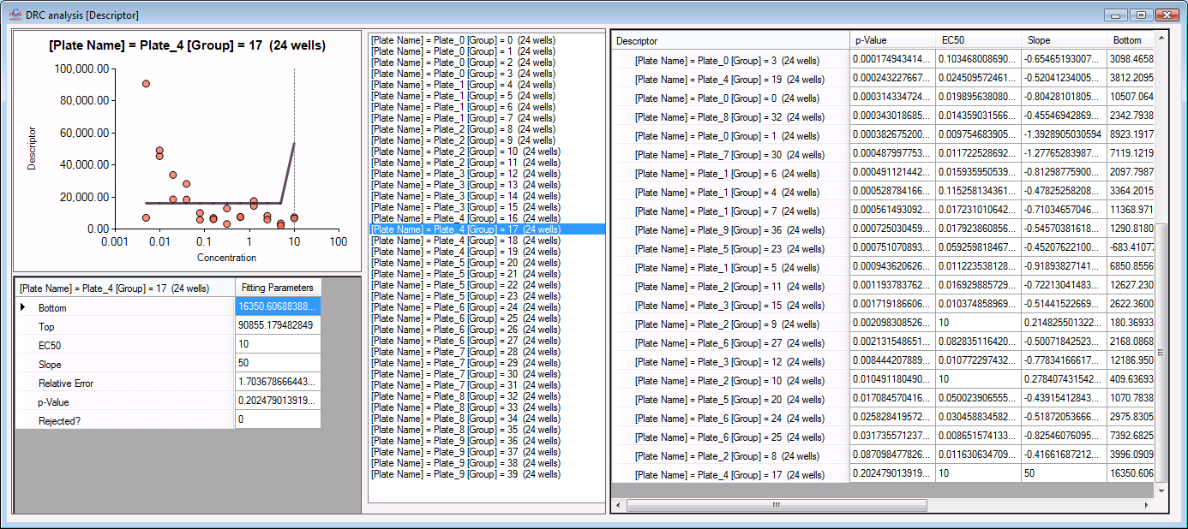

Rem.: don’t forget that the fitting algorithm cannot handle null concentrations (log 0 is not defined in HCSA), and thus any group containing a null concentration will not be processed.

HCS Analyzer v1.2.1.9 (beta)

Let’s start with a little improvement that can save you many nervous breakdowns… just a simple message box asking you to confirm that you really want close HSC-Analyzer.

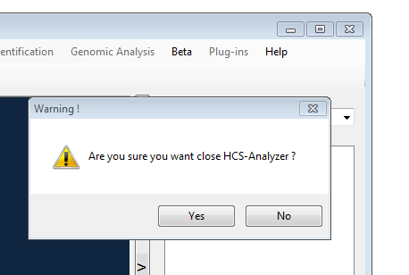

When one working on single cell analysis mode, you can now generate a descriptor that will contain the number of objects contained in one or many classes (not only the ratio as previously implemented).

|  |  |
| --- | --- |
|  |  |

You will find in *Data Visualizatio->Single Cell->Histograms* a way to display automatically the single cell distributions for a specific phenotype contained in a defined set of well within selected plates.

|  |  |  |  |
| --- | --- | --- | --- |
|  |  |  |  |

The histogram is by default normalized and the bin size set to unit.

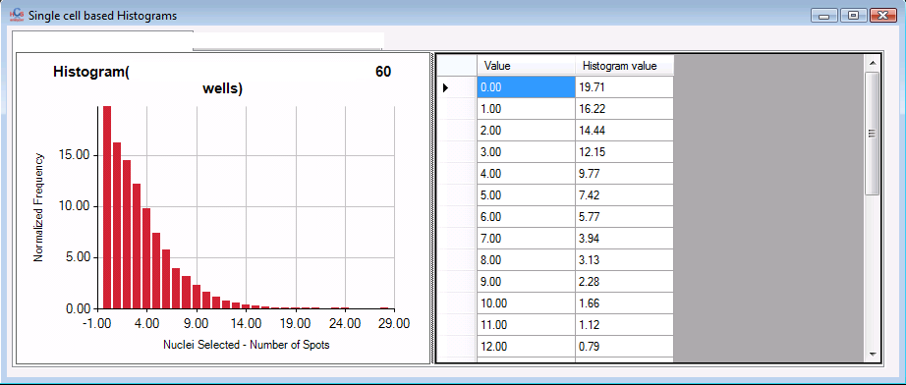

You will probably notice that many menus are displaying a GUI before launching the process. This is coming from a new functionality linked to every component. Every component contains a list of parameters. Those parameters can be automatically requested from the user now. This means that without increasing my workload, the user will be able to customize the processes.

|  |  |
| --- | --- |
|  |  |

New statistical tests have been added to the *Quality Controls* menu: Student t-test and Mann-Withney test for comparing 2 distributions.

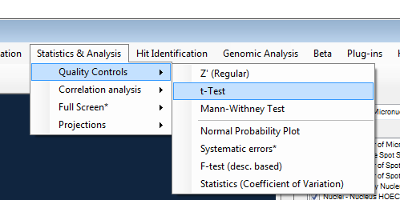

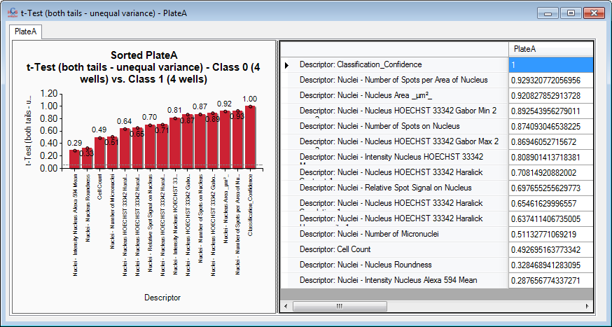

The *list wells* associated menu has been enhanced: you can now extract every single cell based associated value.

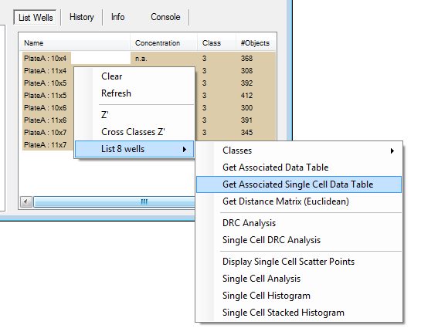

You will also probably notice a new control titled *Plates Selection.* This control control aim is to give you more flexibility in the plates you want process (without going through the *Plate Manager*). Every element of the control is linked to the plates, giving you access to the associated contextual menu.

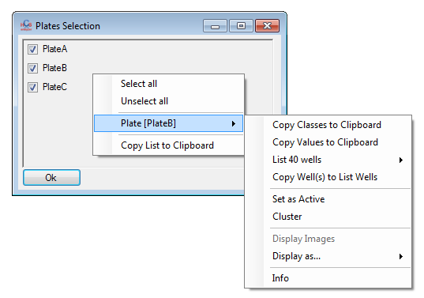

You can also copy the plates list to the clipboard as text.

|  |  |
| --- | --- |
|  |  |

By example, a screening associated context menu gives you the opportunity to copy to the clipboard the values of the current active descriptor. In this case, you can update the plates list before performing the copy by itself (in this case, all the plates are accessible, but only the active ones are checked).

|  |  |
| --- | --- |
|  |  |

You can then paste the results to any kind of software.

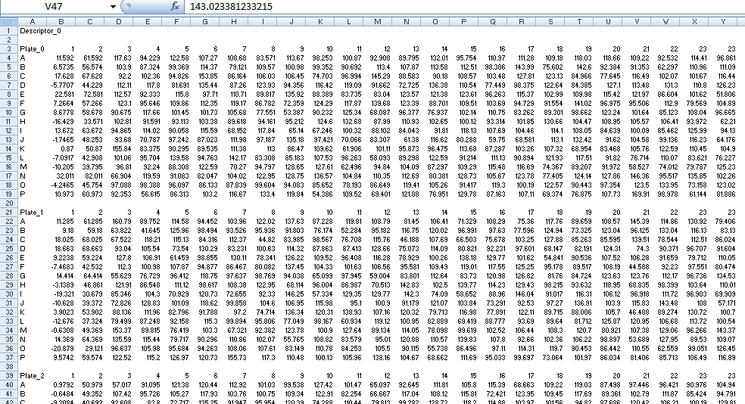

Now let’s talk about a deeper change. In order to begin the implementation of the replicate management, a novel class of properties have been developed and associated to each well (and now to each plate as well). The properties can be anything (string, date, etc...) and you can see them by opening the info window associated to any well.

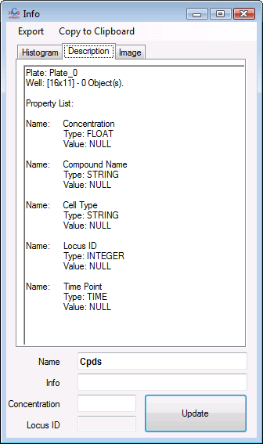

The same kind of custom properties have been associated to each individual plate. Just as an example, when you are computing the Z’ QC of a plate, this value is converted into a floating point value [0..1] that you can checked using the *plate->info* associated context menu.

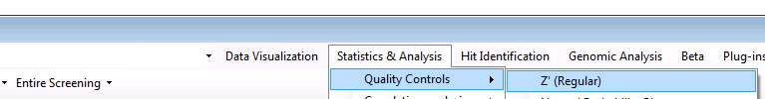

|  |  |
| --- | --- |
|  |  |

The *create average plate* can then take benefit of this information by weighting each plate by its novel associated *Quality* property.

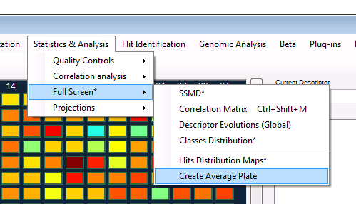

|  |  |
| --- | --- |
|  |  |

In the single cell analysis the bottom histogram is now a stack histogram (easy to identify sub-population within the distribution).

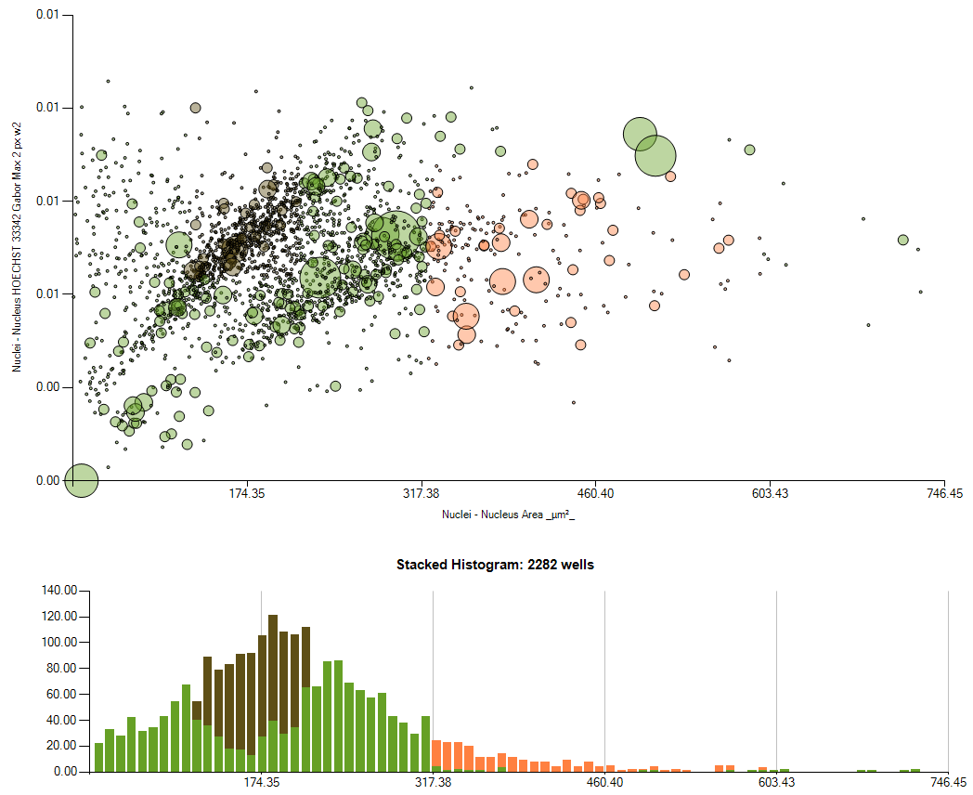

Regarding the graphs, a *Detach* option has been integrated within the *general display* context menu. This cut and paste the current graph into a new window.

|  |  |
| --- | --- |
|  |  |

You will also probably notice on some graph the appearance of dashed line. Typically, one at 0.5 has been added on the Z-factor graph.

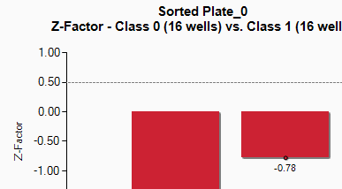

When you are working at the single cell level, phenotype management is improved thanks to a few options:

*Change Phenotype->Swap phenotype* gives the opportunity to swap a series of phenotypes into another one.

|  |  |
| --- | --- |
|  |  |

You can also zoom in on a specific region of the scatter point graph by selecting a region and then click on the *Zoom* context menu.

|  |  |
| --- | --- |
|  |  |

Still in the single cell analysis, when you are performing the classification, you can specify which: biological objects / wells / plates will be subjected to the classification process.

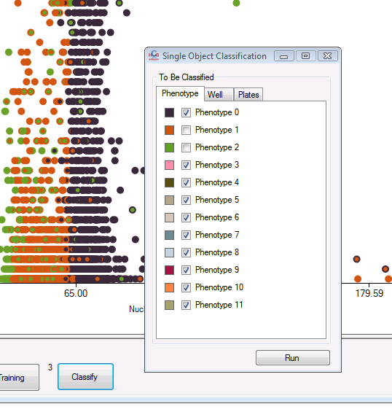

After the classification process, a report window is now displayed, giving you access to the confusion matrix for the entire set of plates and for each individual plate (i.e. how different is the new classification compare to the previous one).

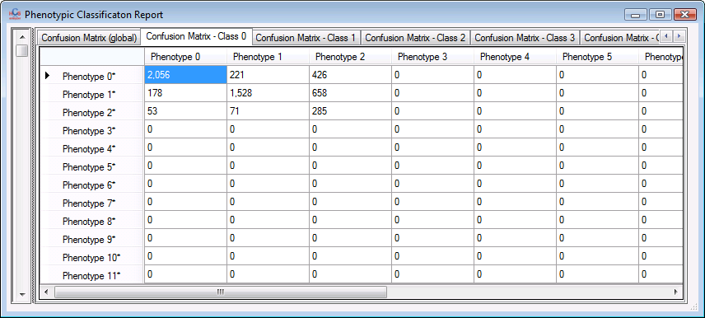

Next to the *Single Analysis* menu of the list wells form, a *Single Cell Stacked Histogram* menu has been added. This allow you to draw the histogram of a set of well at the single cell level while keeping the colour of each sub-population.

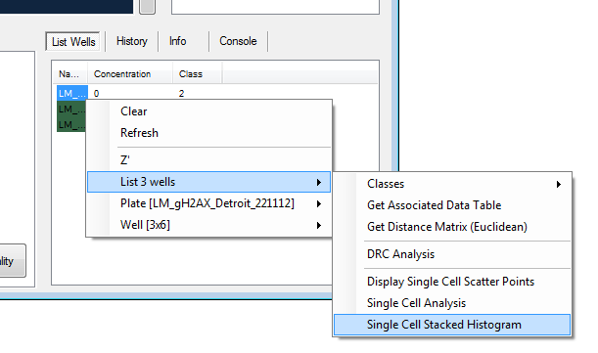

This display is giving me the opportunity to describe a very useful new functionality in term of accessing the data. Typically, in a histogram view, when you display the associated data table, you will access all the raw data from which the histogram is computed. However, sometimes one can be interested by accessing the data of the histogram itself (or one single curve by example). By right clicking on a curve (or histogram) you will see on the associated context menu something like *[Serie] XXX->Display Data Table*.

|  |  |
| --- | --- |
|  |  |

This will open a new window containing the specific series data.

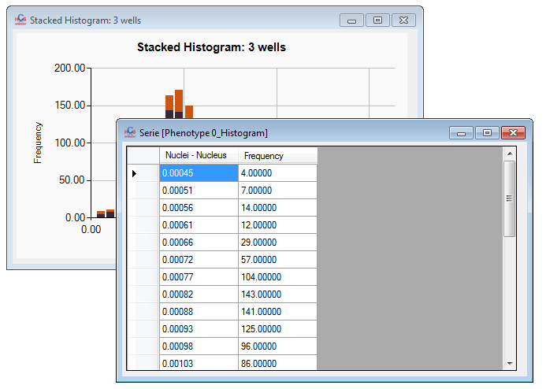

From the descriptor context menu, you can activate *display as Data Table*. This will display a data table containing the state and information about the current set of descriptors that you can copy and paste into your report.

|  |  |
| --- | --- |
|  |  |

You can now compute and display distance between wells by clicking on *List wells->Get Distance Matrix* context menu:

|  |  |
| --- | --- |
|  |  |

This will open a new window containing the distance matrix between wells (based on the active descriptors). From it you can by example display this table as an image:

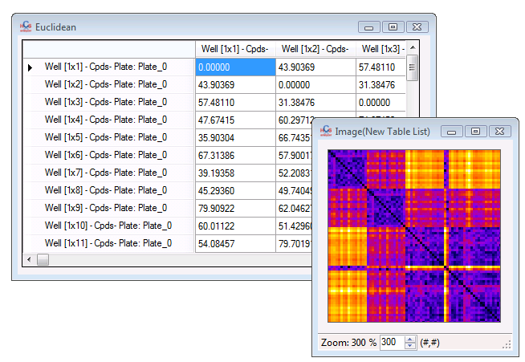

You can also select well(s) (Remember: Left click <=> one single well, Left Click + Ctrl <=> all the wells from the same class from the same plate, Left Click + Shift + Ctrl <=> all the wells from the same class from the entire screening), and drag and drop them on another one. This will display a window containing the different accessible metrics between each individual wells.

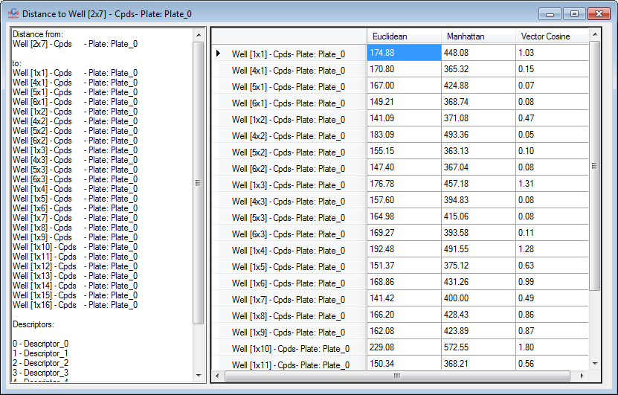

A few options have been added in the Data Table display context menu. By example, you can now rotate your table by clicking on *Operations->Transpose*.

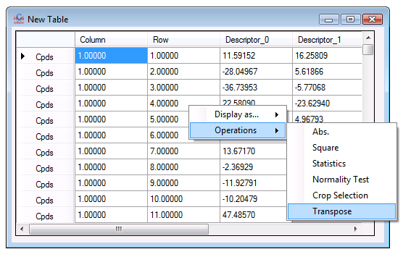

You will probable notice an *Info* tab at the bottom right of the application window. This displays a report about the current screening status. Don’t hesitate to *Refresh* it.

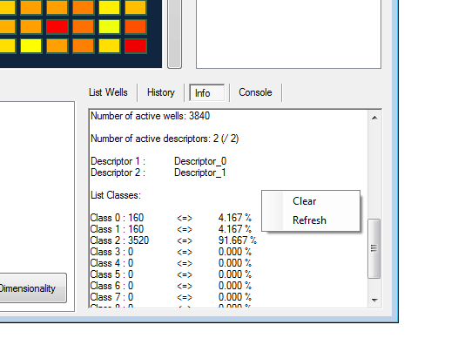

In the heat map display, the tooltip contains now the X and Y names.

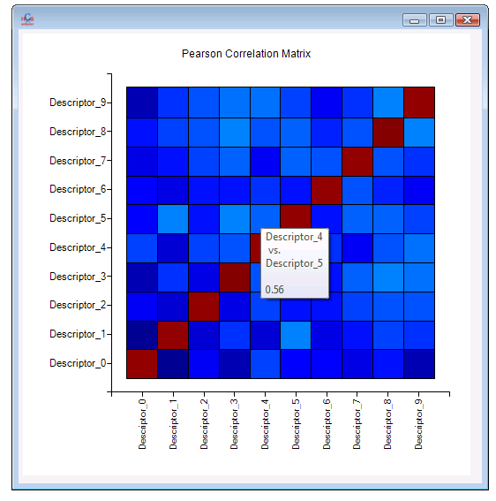

HCS Analyzer v1.2.1.8 (beta)

First, a tiny but useful improvement: when one displaying 1D scatter points from an entire screening, each plate is separated by a vertical line.

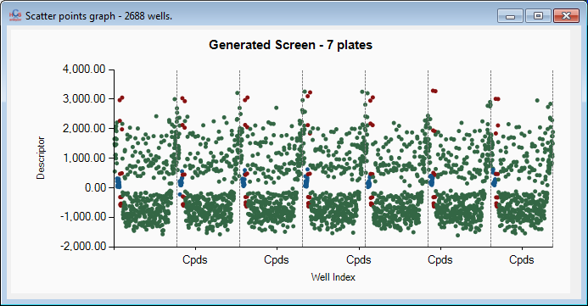

Now in the quality control category, you can now choose between Regular and Robust Z-factor (named Z’ as well) by right clicking on the *Statistics & Analysis->Quality Controls->Z’ item*.

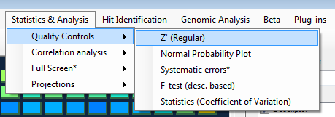

In the 2D scatter point view, after drawing a selection, you can zoom in into it by using the zoom option in the context menu.

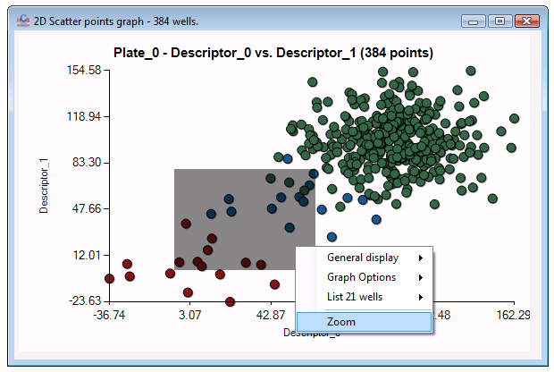

The Descriptors Filtering (accessible from the descriptor context menu) can be used multiple times without closing the window by using “Apply” button.

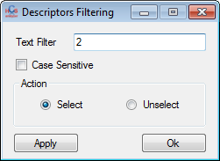

The *Wells List* control has been enhanced:

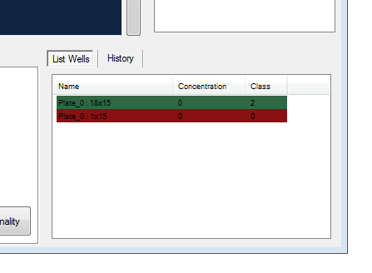

The row colour corresponds to the class colour and the concentration, as well as the well class, is displayed. You can press *F5* to refresh the values.

You’ll notice too that the *Single Cell Analysis* tab has disappeared. You can now access it through the list Wells context menu (through which you can also compute the Z factor).

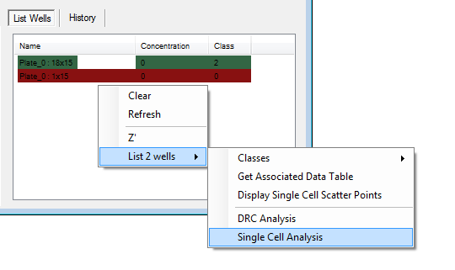

Next to the *List Wells* tab, you will find the *History* tab that’ll display the previously saved classes of the each screening well.

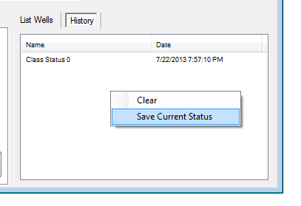

You can save the current status by clicking on the associated context menu, and activate a selected history by either activating its context menu or double clicking on it.

An interactive look up table has been integrated to the user interface:

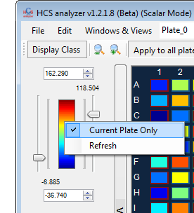

You can now change the maximum and minimum value of the signal by moving the associated sliders. A context menu gives you the opportunity to refresh the min and max, as well as, makes them relative to the current plate or the entire active screening.

HCS Analyzer v1.2.1.7 (beta)

The first thing that you will probably notice about this new version is the novel location of the *List Wells* control that is now no more associated to the single cell analysis but is much more general.

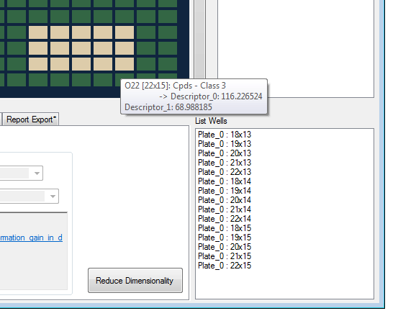

This will allow to perform analysis on a sub list of the wells. You can drag and drop wells directly from the current plate. By pressing Shift while dragging the well, every well from the same class will be moved to the list. If pressing Ctrl+Shift and dragging well, all the wells of the same class over the entire screening will be moved.

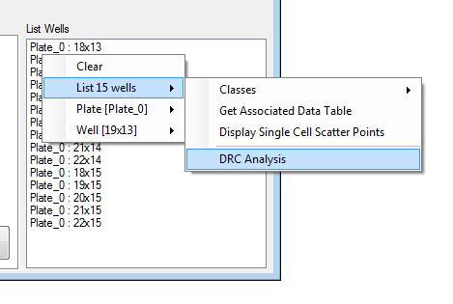

One of the new feature is DRC (Dose Response Analysis) that will display a DRC report for each active descritpor (You need to have concentration values associated to perform this operation).

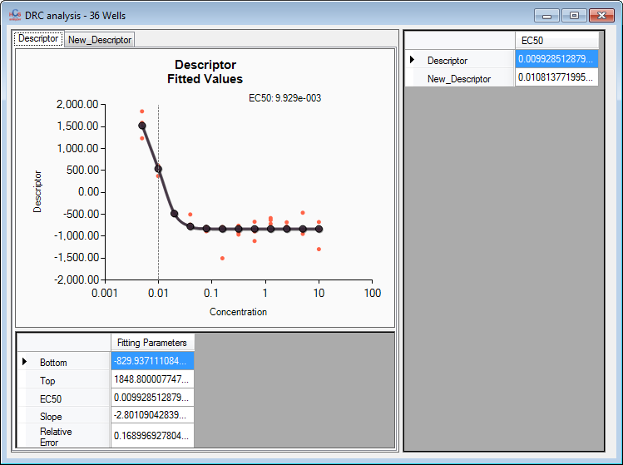

I added also *Load Plate Concentrations* working excatly the same way as *Load Plate Map.*

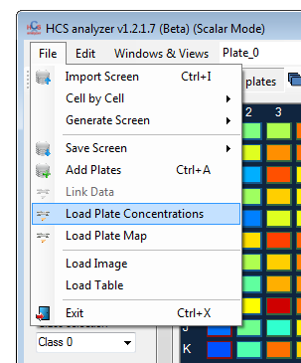

In the image analysis, when one displaying elevation map, the active color look up table is transfer to the 3D view.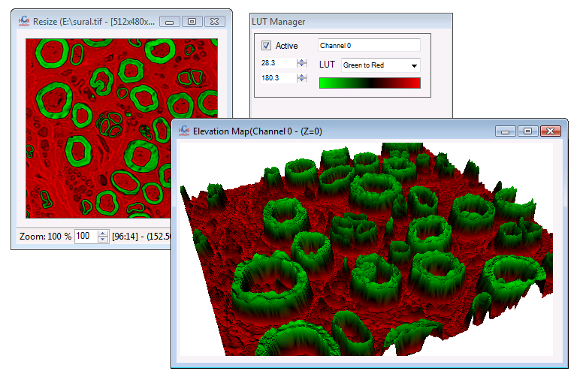

The *File->Cell by Cell->CSV -> DB* is now an indenpendant process. The conversion process has been mutlithreaded, which means that you can use HCS Analyzer while the conversion is operated.

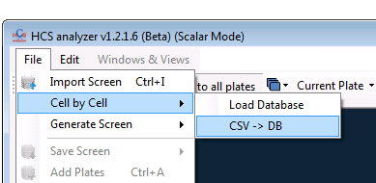

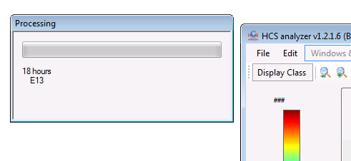

Many other processes will be migrated to a multithreaded approach pretty soon.

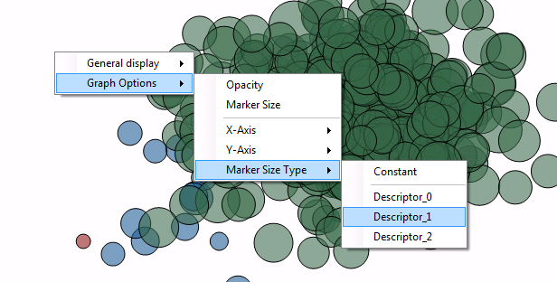

A very useful and important feature has been added to

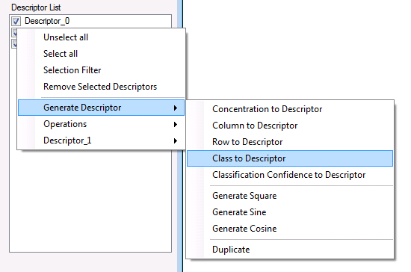

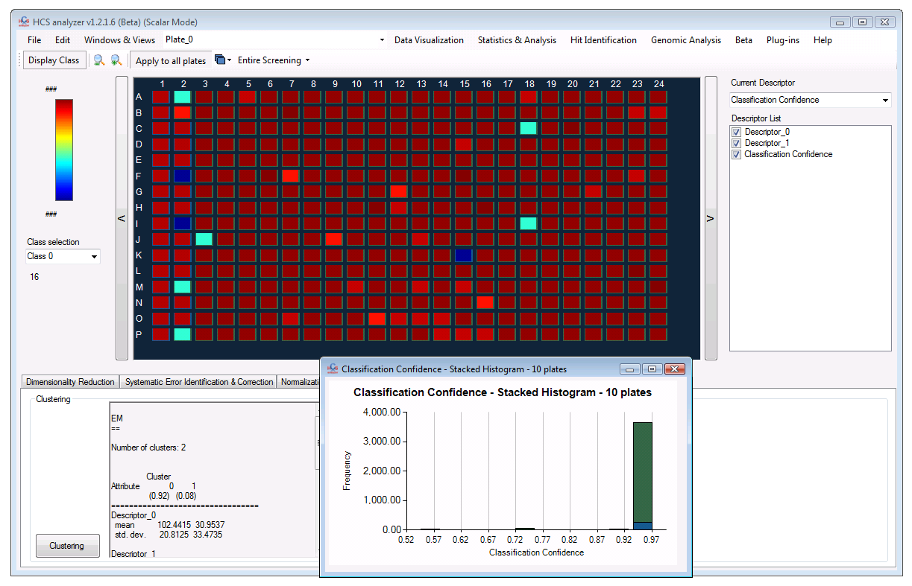

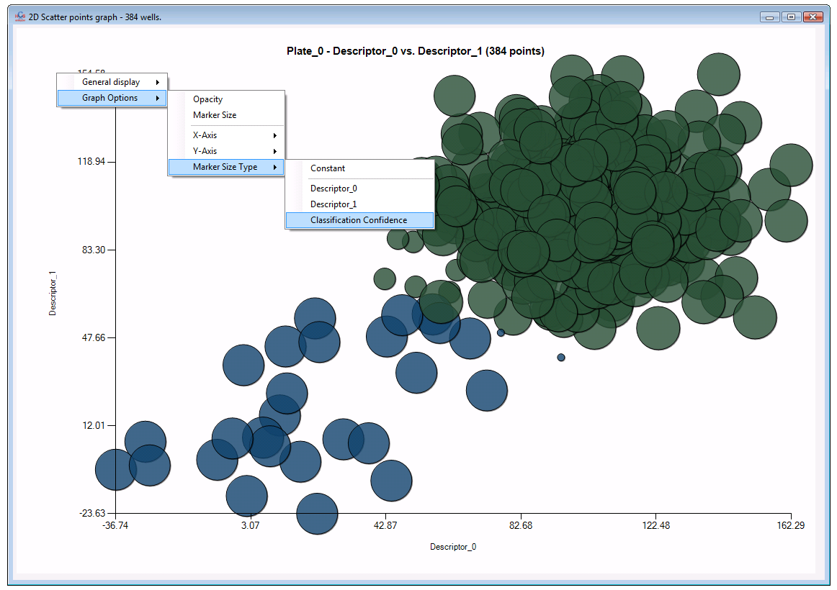

HCS Analyzer v1.2.1.6 (beta)

Here is the short list of new improvements added to the v1.2.1.6.

First, when converting CSV-DB for single cell analysis, a window is displayed giving you a precise feedback about the conversion process (this will be shortly generalized to every IO process):

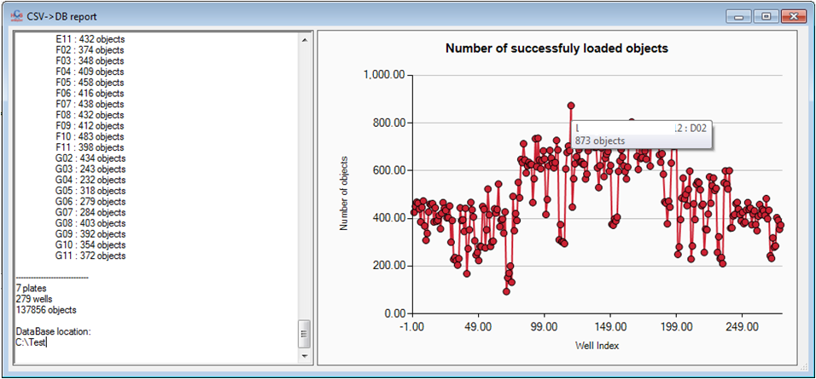

In *Quality Controls->Normal Probability Plot* has been moved to the new paradigm 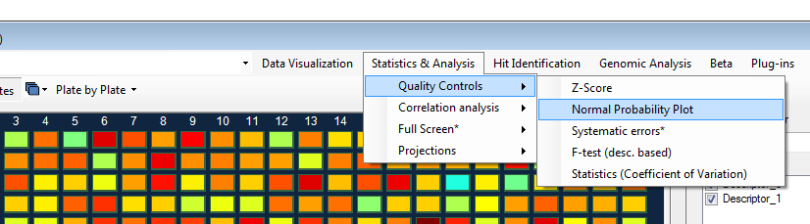

(accessible by the context menu of any Data Table Viewer as well).

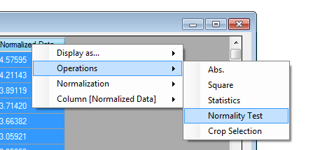

This will give you access to a complete univariate normality report containing Normal Probability Plot and many other features. This is again entirely linked to the current screening and takes into account the process type (single plate, plate by plate or full screening).

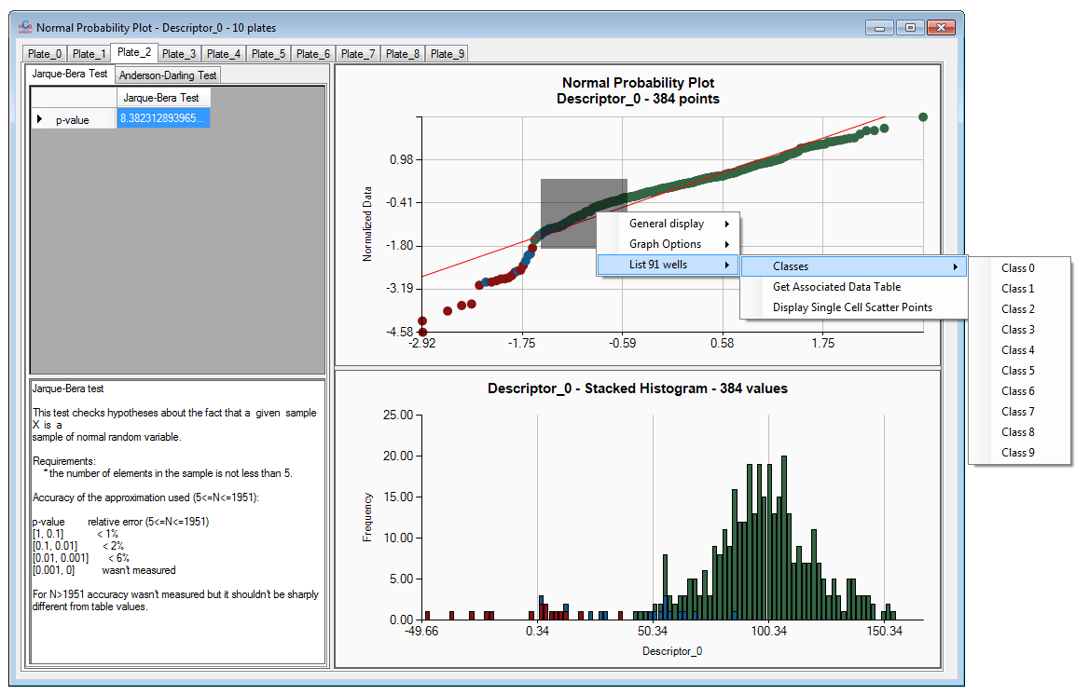

You will also find in the *Hit Identification->Validation->Classification Significance*, a list of tests to assess the robustness of the classes.

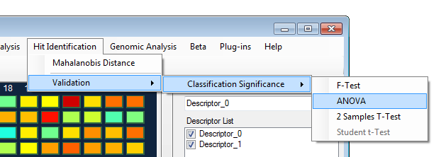

These tests are univariate and based on the current selected descriptors.

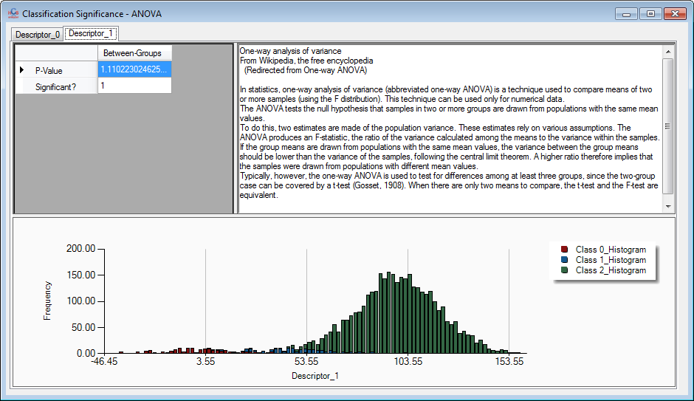

HCS Analyzer v1.2.1.5 (beta)

As usual a lot of new improvements for this novel version of HCS Analyzer (but it is still a Beta).

First let’s talk about single cells. I recently defined a novel object called *cListWells* implementing many interesting features. Some of them are directly accessible through a context menu. You will see that by right clicking on the text box of the *Single Cell Analysis* tab, as shown on the following figure:

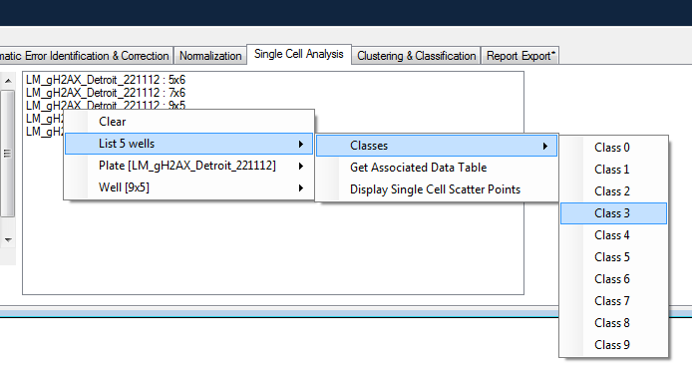

You can modify the well classes, extract the associated data table or display the associated 2D scatter point graph. Many other features will come in a near future.

Let’s move to the single cell analysis. As you will notice, the interaction with the scatter point has been greatly improved. You can now select point and modify their associated classes (call phenotypes in this case)

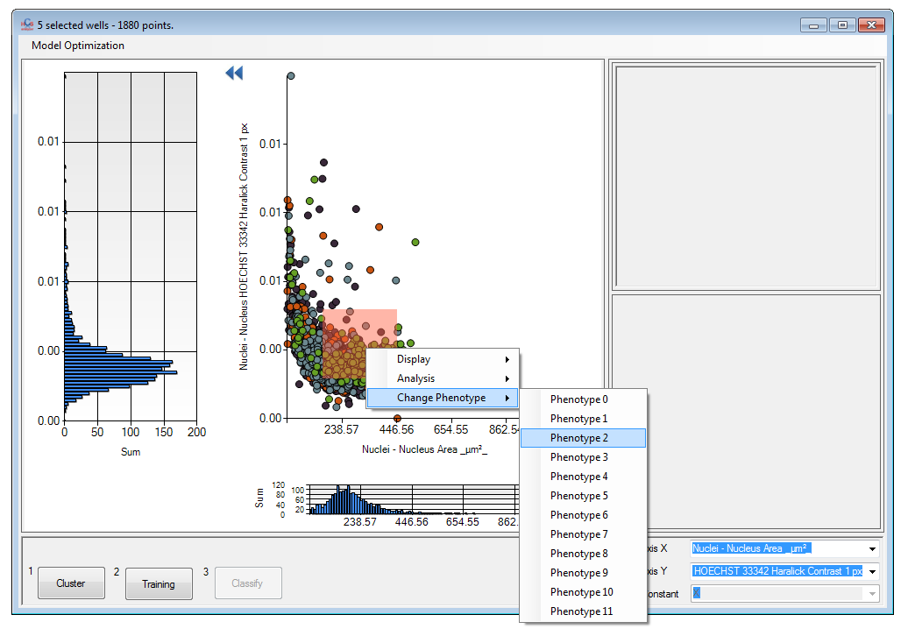

and also perform many other operations through the context menu (like modifying the graph appearance and performing analysis).

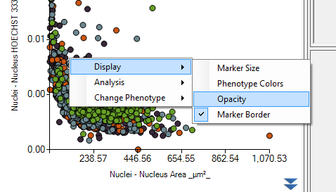

You will also find a completely new application in the *Model Optimization->Sub Population Identification* (temporary location). To make a long story short, this is an automated algorithm that should allow you to distinguish overlapping phenotypes from phenotype of interest and thus focus your strategy only on a sub-population of interest. This is still under development, but the preliminary results are promising. Anyway, I will probably talk more about it in a future release.

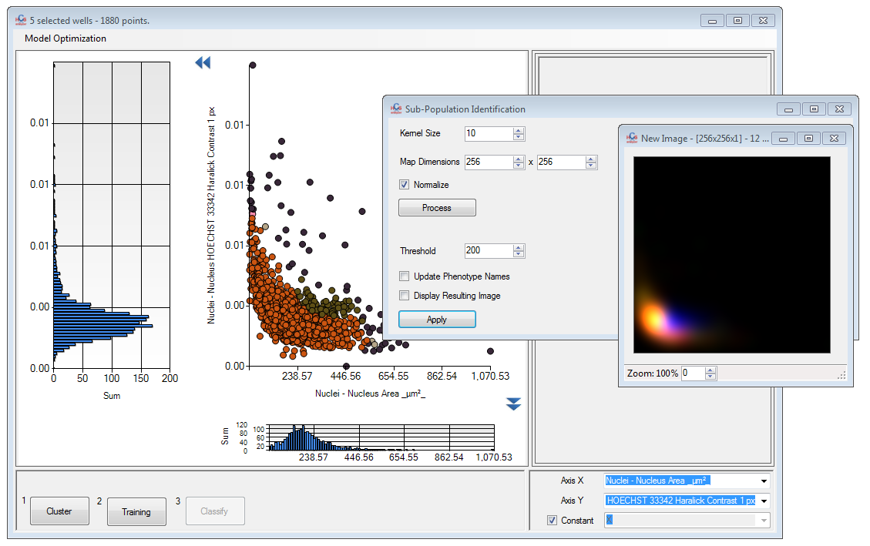

When working on cell-by-cell you can now follow the evolution of the distribution of one (or more) class within the entire set of active plates. To do that, right click on *Statistics & Analysis-> Full Screen->Descriptor Evolutions* and switch to *Cell-by-Cell*. Then activate the process by clicking on the menu.

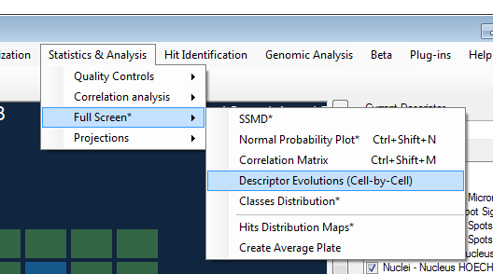

A graph similar to the one below should appear.

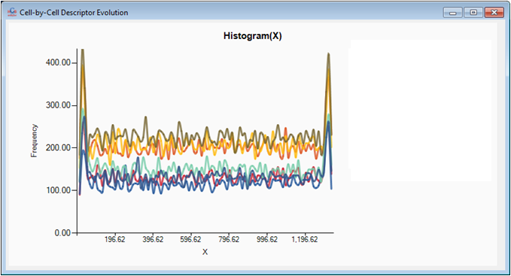

Finally, let’s talk about image analysis. You will notice a in the *File* menu a *Load Image* option.

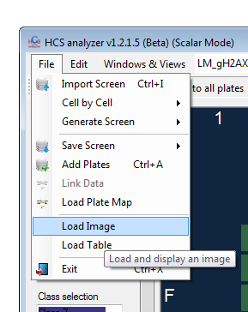

You will be able to load a lot of different file type. For the moment, this has been included in HCS analyzer for testing purpose only. However, you can enjoy the temporary interface. By right clicking on the image you will have access to many different options. By example the LUT Manager gives you the opportunity to modify the image display channel by channel.

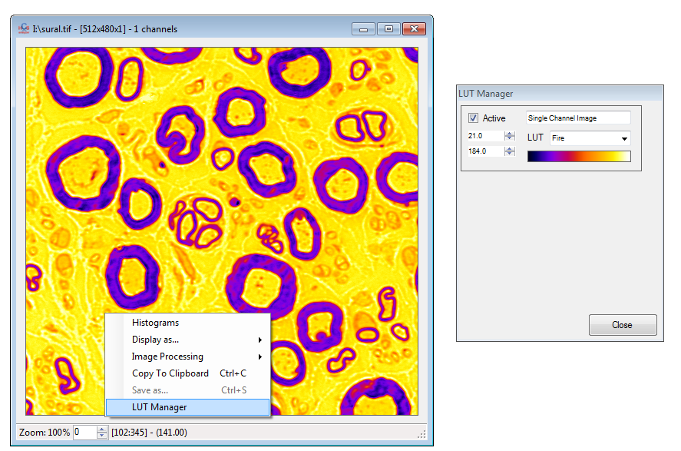

You will find as well some image processing algorithms (again for testing purpose).

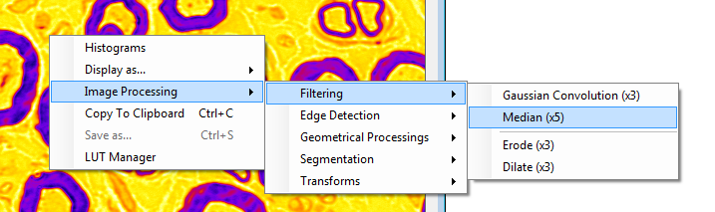

Through the LUT manager you will have access to other options such as *Display as…->Elevation Map* (warning this can take time).

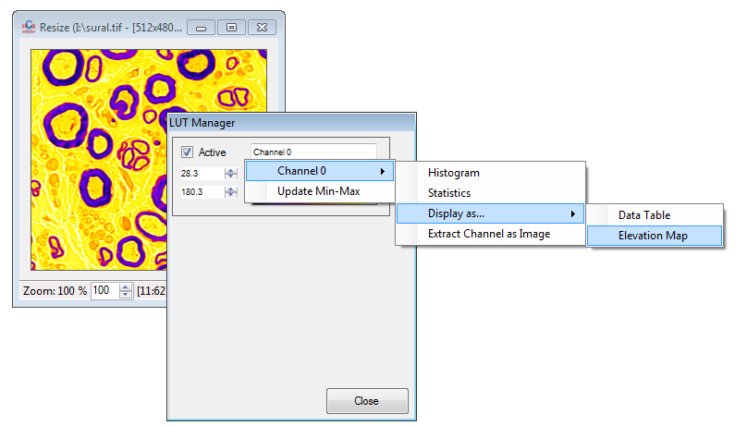

This option will display a 3D representation of the current single channel image.

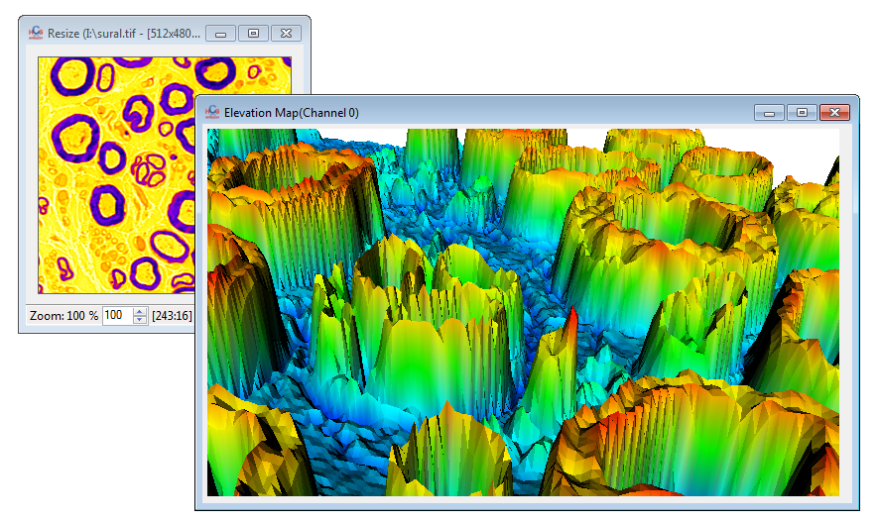

You can also convert the image into a Data Table and display it (Warning: Windows Data Table display has some limitations in size and thus only small images can be process this way), giving you access to all the regular operations related to this display.

HCS Analyzer v1.2.1.4 (beta)

Another useful feature has been added to the table context menu: *Operations->Min-Max*

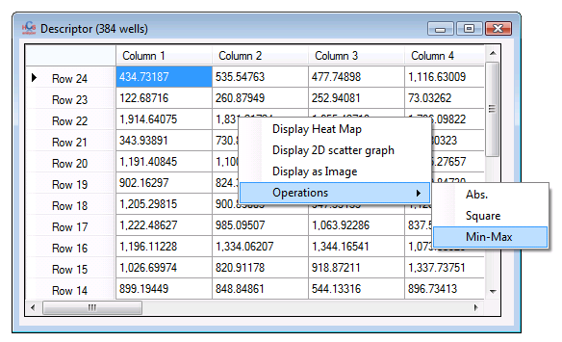

As you can imagine this display a table containing respectively the minimum and the maximum of the complete table.

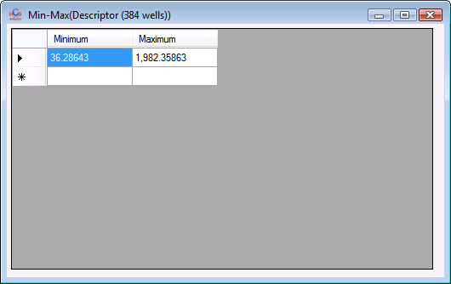

Multiple significance tests have been added to the core and are directly accessible through the table context menu:

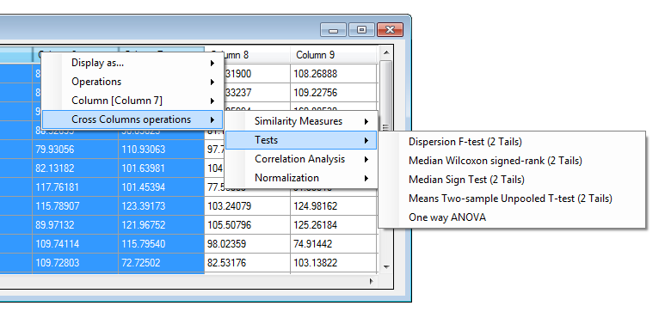

You can now load a plate design directly from a CSV file.

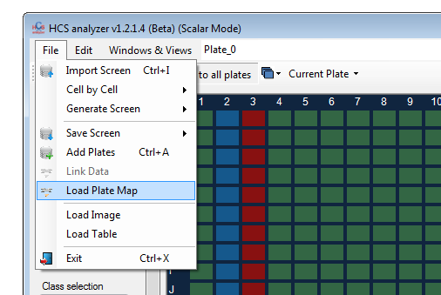

The .CSV file format is pretty straightforward (you can find an example below): each cell contain the class value, except for the first row and column .

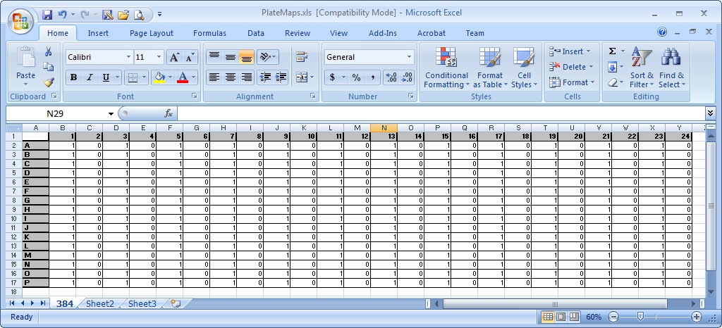

Thanks to that you will be able to store and load easily your experiment or screening plate design.

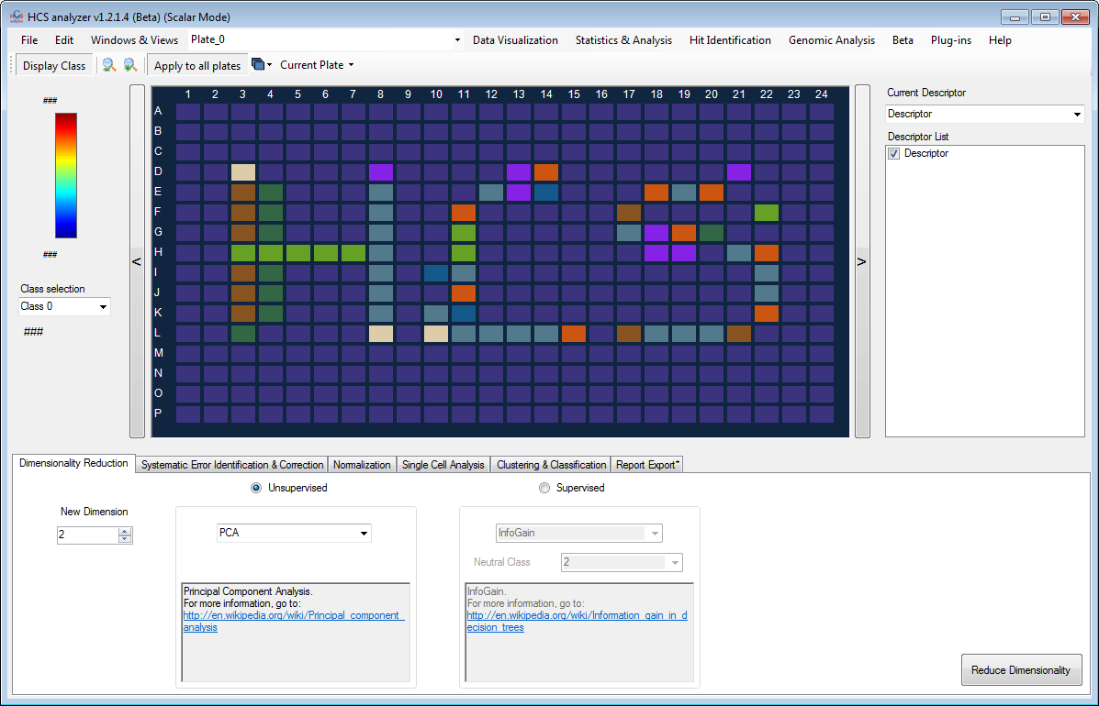

Different options for graph display have been added. By example, you can now increase or decrease the graph line width.

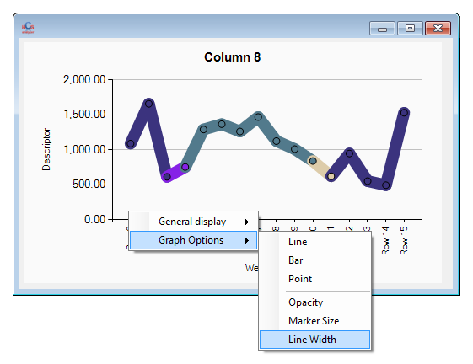

As the new paradigm is quite general, I gave the user the opportunity to use HCS analyzer to process external data. This can be achieved by loading a CSV table using the *File->Load Table* option.

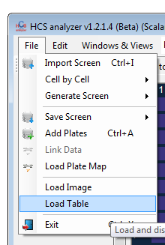

The Z factor display has been enhanced: a table is now attached to the histogram for a better visibility.

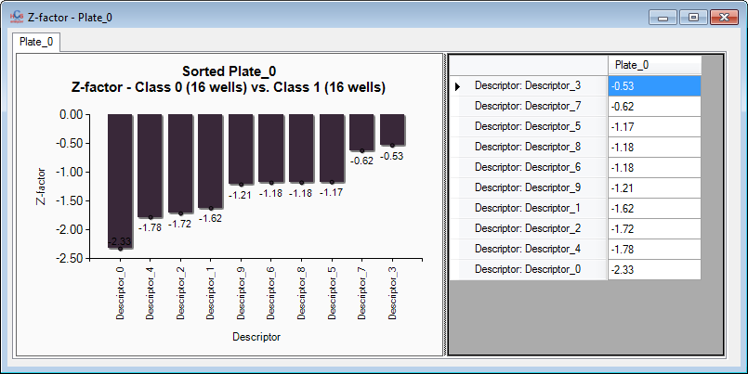

If you are dealing with a large number of descriptor, it is sometimes difficult to locate specific descriptor. In order to fix that, I added a *Selection Filter* option in the descriptor context menu.

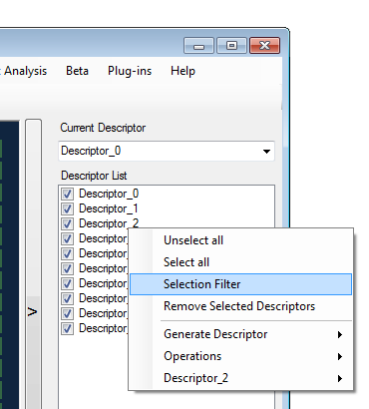

This allows you to select or unselect descriptors containing a specific string of characters.

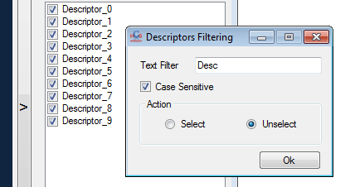

A novel algorithm for hit identification has been added (hopefully the first of a long serie). Go to the menu *Hit Identification->Mahalanobis Distance*.  
In this process, hits are defined by a threshold of the Mahalanobis distance to one (or more) class of points. *Hits new class* specifies class identify of the hits.

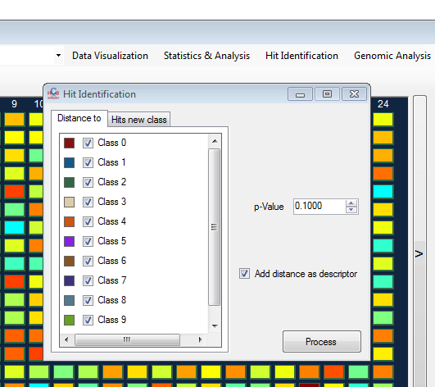

Here is a 3D visual representation of screening before:

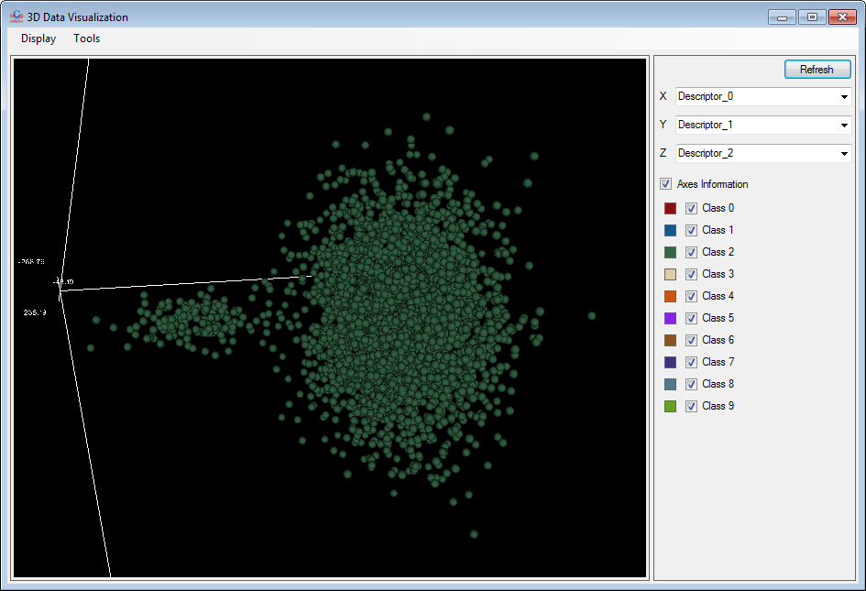

And after hits identification:

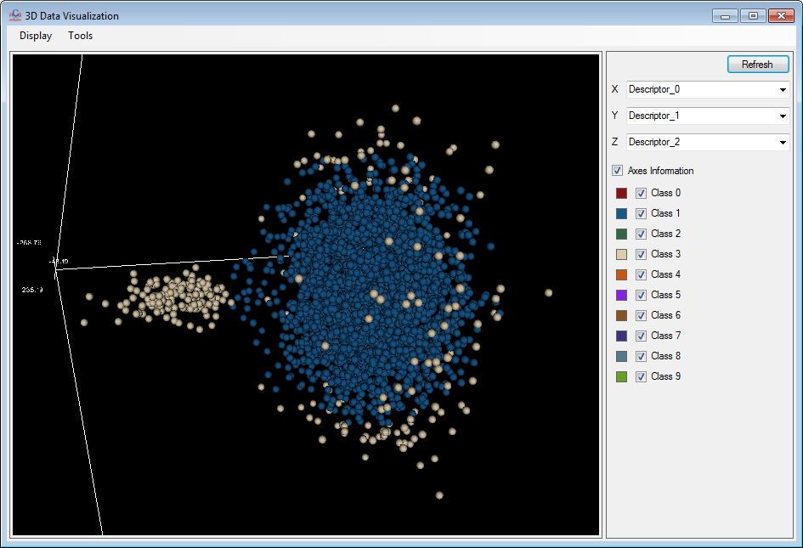

When using the Data Table display one can now extract a sub-part of the table by first selecting the region of interest and then using the context menu: *Operations->Crop Selection.*

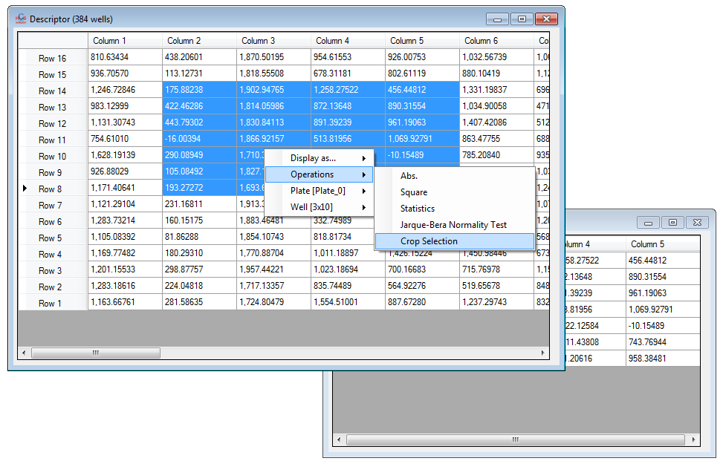

Finally the statistics menu has been extended again:

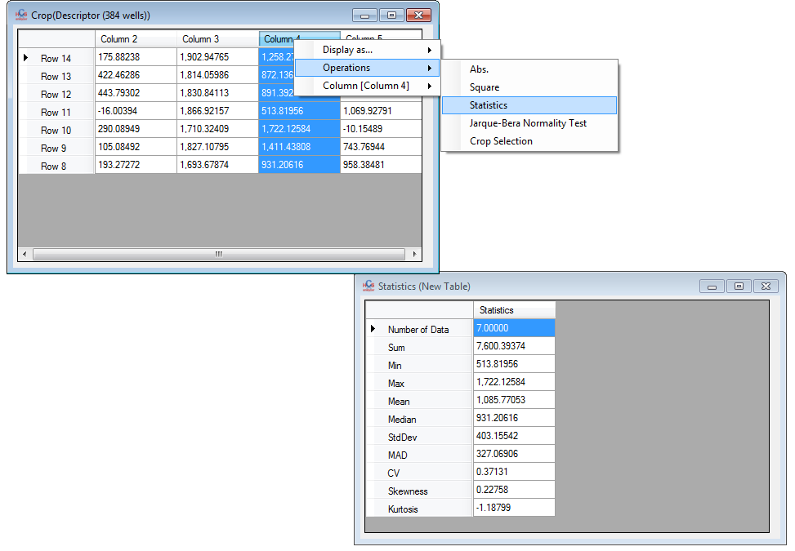

HCS Analyzer v1.2.1.3 (beta)

This week has been single cell oriented. I am gently migrating the single cell analysis to the new paradigm. In this respect, things are changing in the database creation, and unfortunately, the previous database are no more compatible with the new version.

The main change can be seen when generating a database from a CSV file: you will notice a new value in the drop box menu (and this changes everything as you will see):

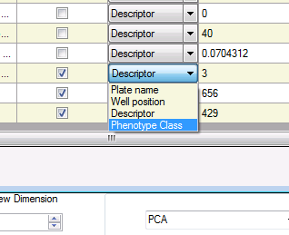

If you performed any kind of supervised classification of your biological objects prior to the CSV file creation, you can select it using *Phenotype Class* (please keep in mind that the number of phenotypes is limited to 12 for the moment). If you do not associate it, every biological object will have 0 as default phenotypic class value.

This means that now every single object has its own class, just like a well, embedded within the database.

Later on, if you try to load a database generated by a previous version of HCSAnalyser, the software will detect that Phenotype_Class column does not exist and thus propose you to create it.

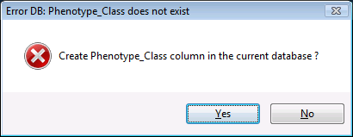

In this case, the default value is set to 0.

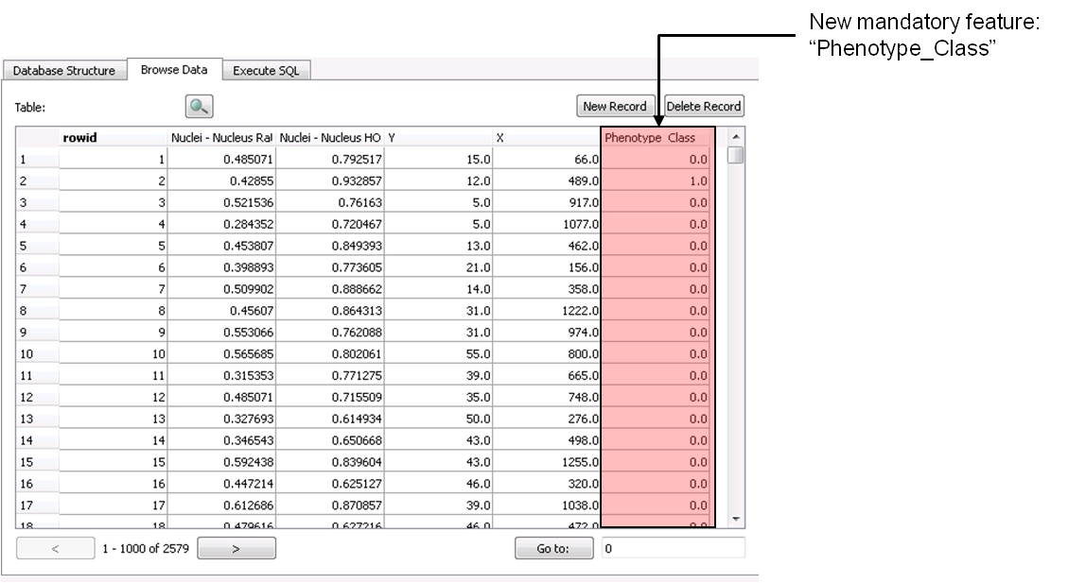

Currently (and probably forever) the only way to modify those classes is to go through the classification process of the single cell analysis.

Let’s take a look at what we can achieve now. First select your wells of interest as usual, and then go to the *Single Cell Analysis* tab:

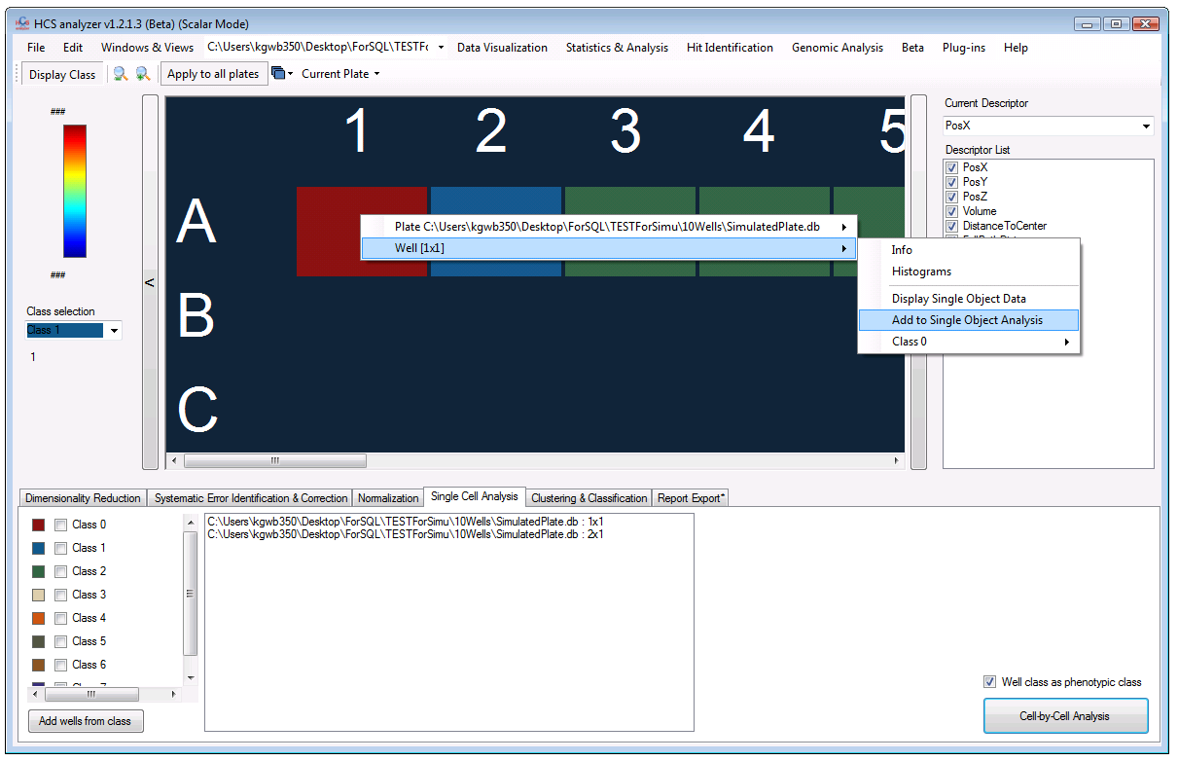

As you can notice there is now a novel check box named *Well class as Phenotypic class.* If this is checked, this will override the current phenotype class associated for each single object within the database (but don’t worry it will not modify the Database) and associated to each object the class index of the well it belongs to.

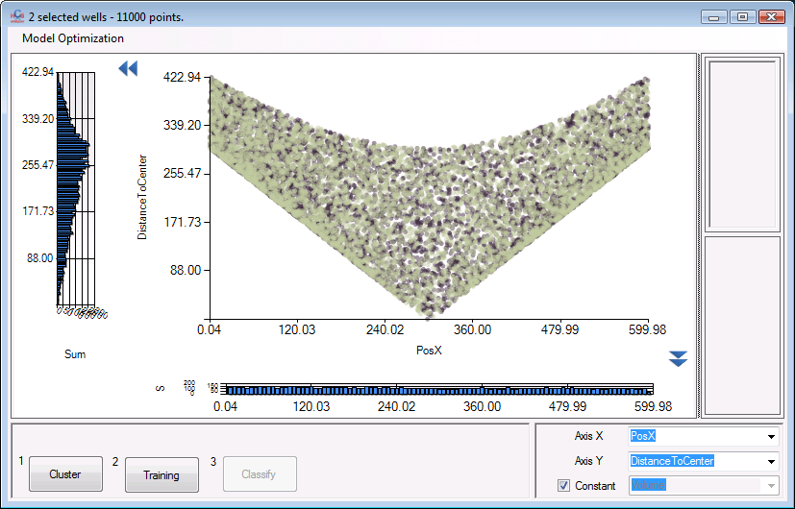

You can then perform your clustering/training processes as usual. Then it is time to classify the entire screening by pressing *Classify*:

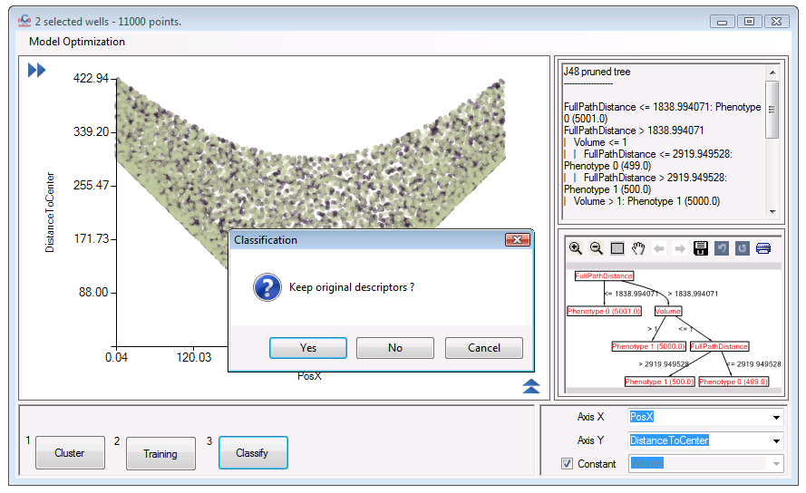

This will as usual generate N new descriptors representing the ratio of each phenotype within each well but also (and that’s the novelty) update each individual object class. You can check this by displaying well single objects:

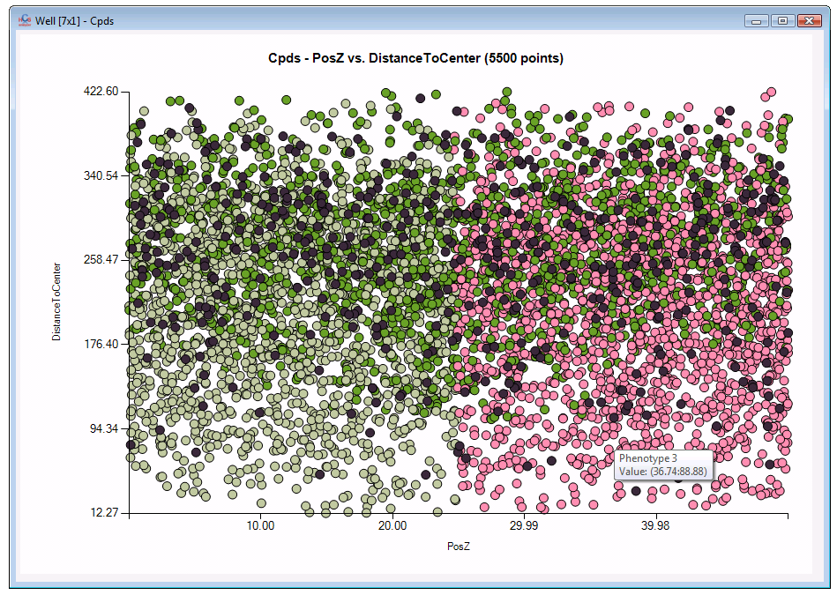

Each object has now its own class and thus its own colour. The advantage of it, is that now we are able to generate descriptors from a statistical analysis of a subpopulation. By right clicking on a descriptor you can now access an option called *average*:

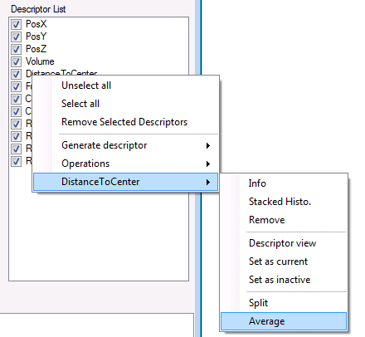

And then select the phenotype of interest you want compute the average on:

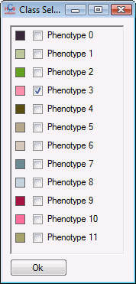

A new descriptor is then computed and added to the list:

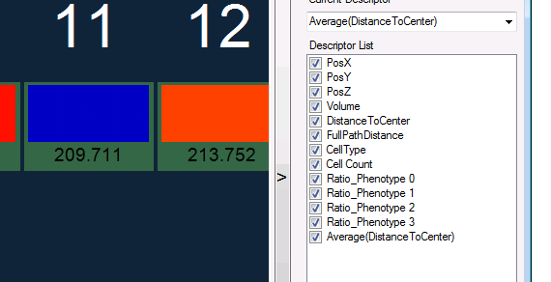

You can keep track of the way the descriptor has been created by displaying the info window related to this descriptor:

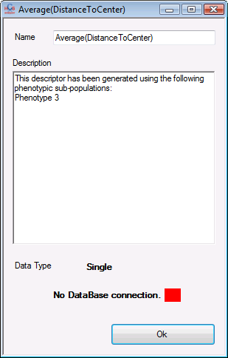

Now that this high level “gating” has been developed it opens opportunity to computes any kind of features over a single or a combination of biological subpopulation.

A statistic analysis of your data has been added and placed within the new data format paradigm. One can access it by clicking on: *Statistics & Analysis->Quality Controls->Statistics*

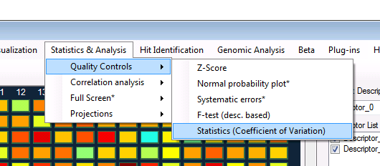

By default the statistic is set up to *Coefficient of Variation* and will be computed over the wells of the defined class(es). This will take into account as usual your process mode and thus give different visualization regarding the selected mode (Current plate, Entire screen, plate by plate), just like the Z’ factor.

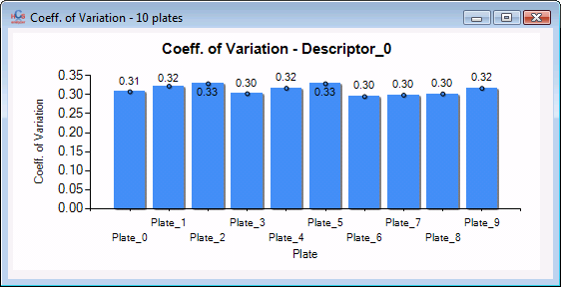

However you can change the statistical feature by right clicking on the *Statistics & Analysis->Quality Controls->Statistics* menu. Then another contextual menu will popup, giving the user the opportunity to switch from one feature to another:

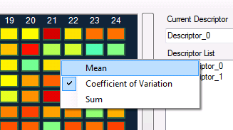

A *Descending sorting* component has been added. The user can use it through the *Data manipulations->Descending sorting* by example.

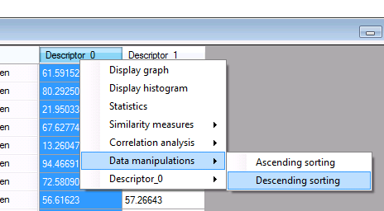

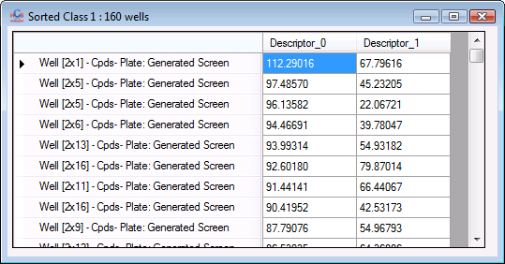

You can select the classes of interest before displaying a 1D scatter point graph.

|  |  |
| --- | --- |
|  |  |

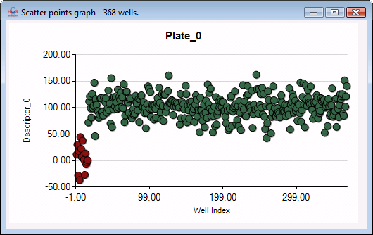

Autocompletion has been added to the current descriptor drop box (can be useful to find out a descriptor when you are dealing with a high number of them).

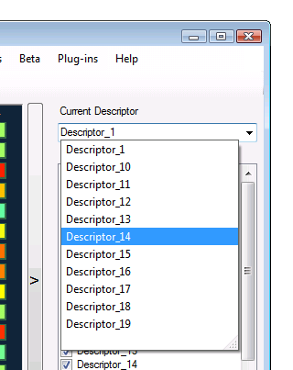

HCS Analyzer v1.2.1.2 (beta)

For convenience, the current process mode is always visible:

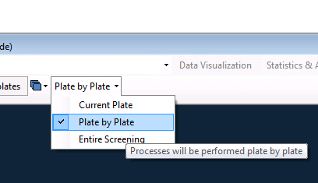

The class related menu has been included in the well context menu and is thus always accessible:

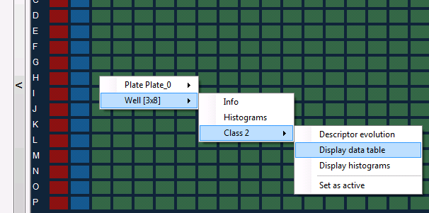

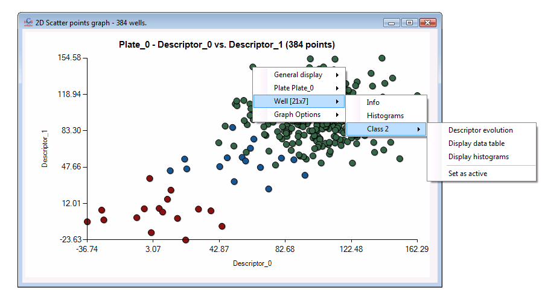

Two new menus have been added:  
*Display data table*, that shows a window containing the data of every well of the screening from the selected class

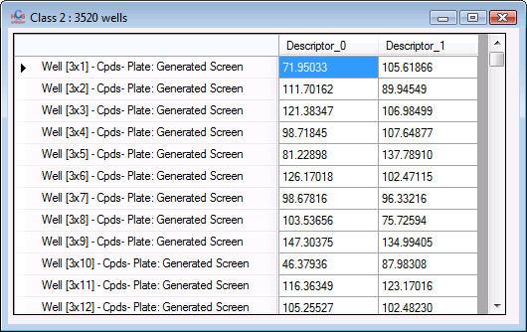

And *display histograms* that displays a window containing the histograms of the distribution of the selected class (of the active descriptor) for the entire screening (top) and the current plate (bottom)

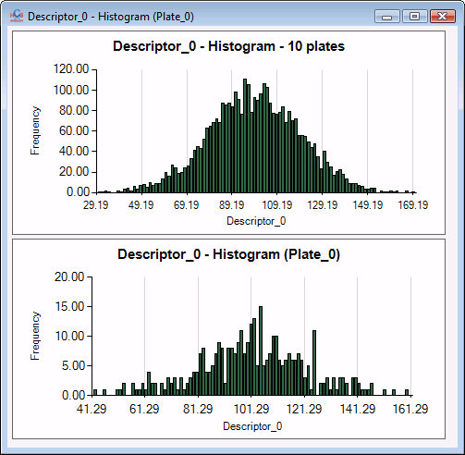

Moreover, *statistics* component

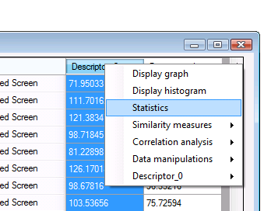

has been extended, and now contains *Skewness* and *Kurtosis*

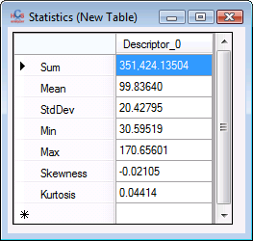

I added a user interface for modifying the X-Y axis minimum and maximum for any kind of chart visualization:

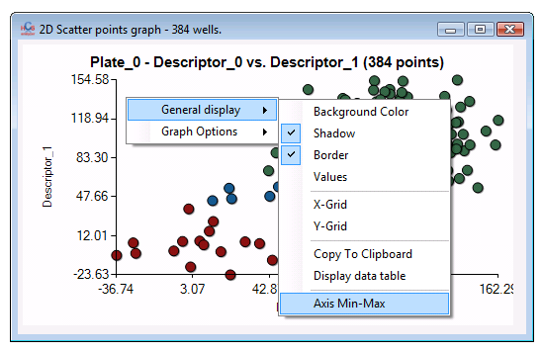

Here is an example:

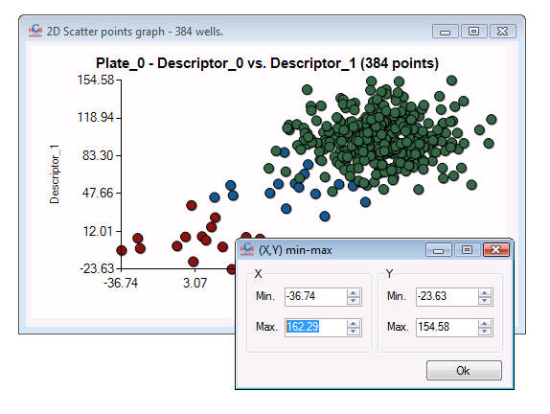

And then:

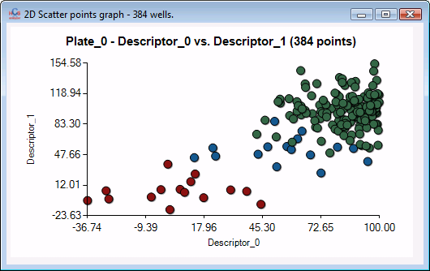

You can also associate a descriptor to the marker radius in 2D scatter point graph:

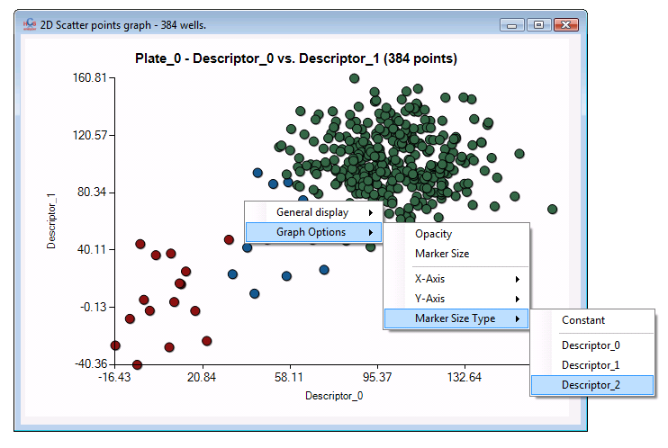

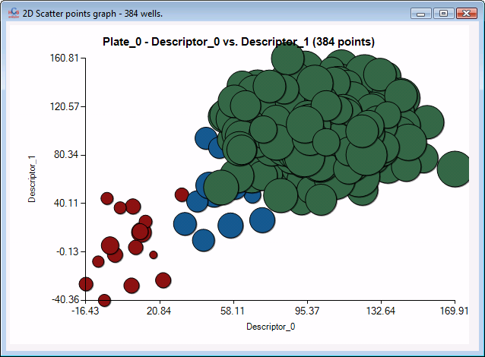

For those working on single cell analysis, I updated the single well data view into the new format:

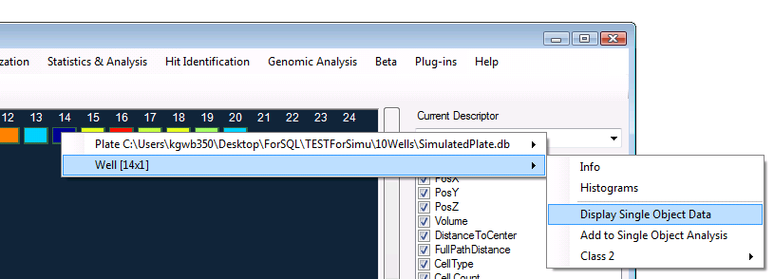

And then you can enjoy all the associated tools related to the new data format:

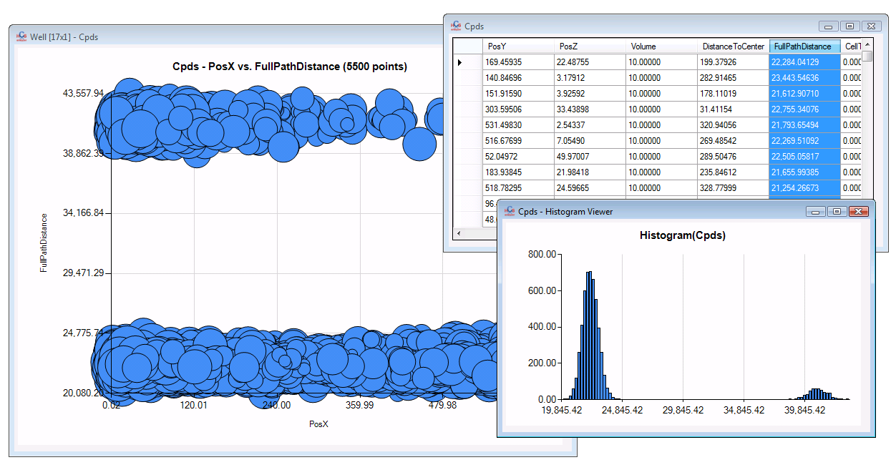

Finally, a *set as inactive* option has been added to the descriptor context menu. That can be useful to reject descriptors for future analysis while analysing data such as Z’ factor (*Quality controls*)

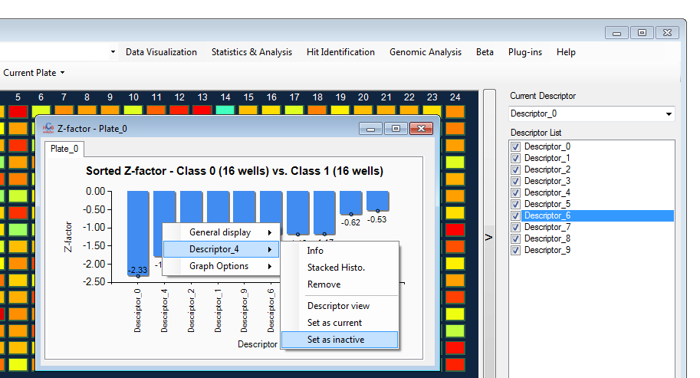

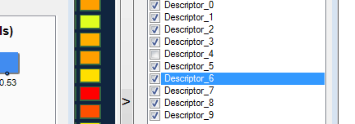

HCS Analyzer v1.2.1.1 (beta)

As I said last week, thanks to the new core, HCS Analyzer development is getting much faster and robust. I am currently expanding all the obsolete functions to the new paradigm. Let’s give you a quick overview of what has changed this week. First of all you’ll notice that the menus are getting simpler.  
However, more options are available through the menus.

As an example, when one click on column, here is what you see:

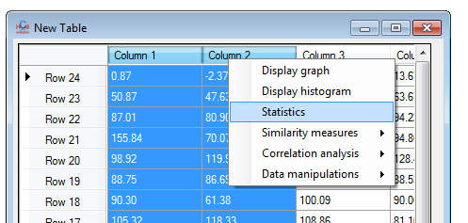

If you click on statistics, it’ll generate another table containing some statistical information about the selected columns:

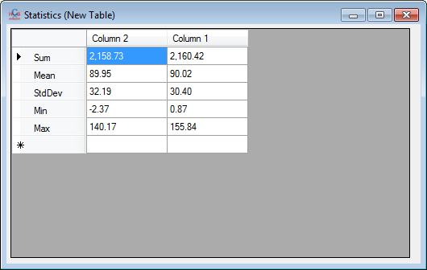

But you can also access similarity measures:

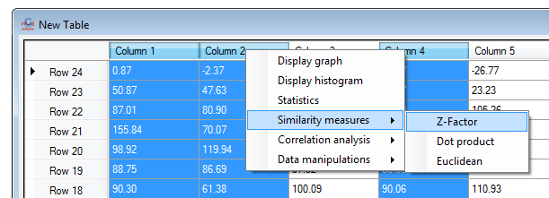

Clicking on one of them will generate a table that you can display with more appropriate components:

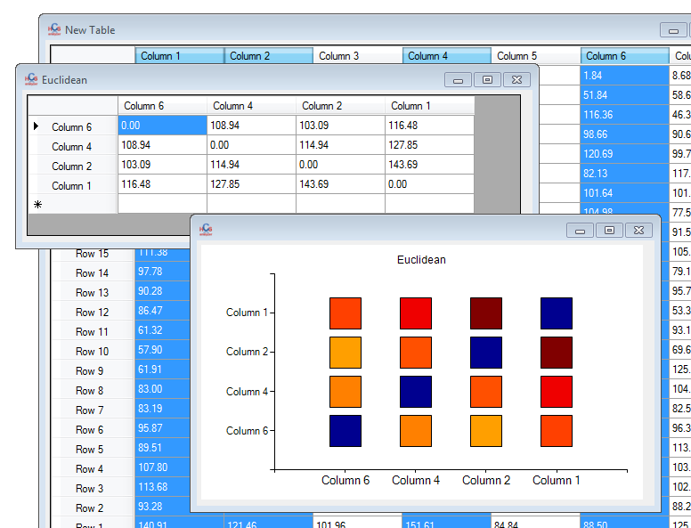

But you can compute also correlation measures (useful when one wants to identify correlations between descriptors). We are here performing a MINE analysis to identify non linear correlations.

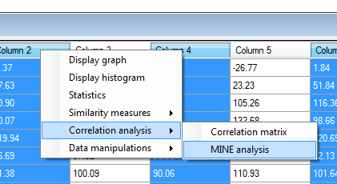

In this case, many tables are available:

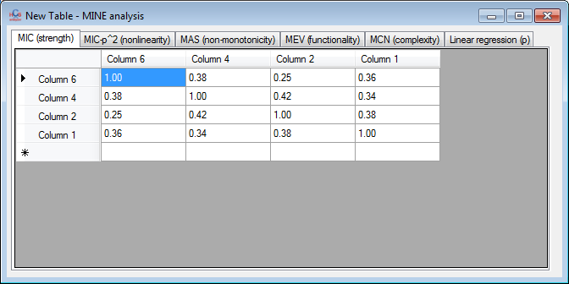

Finally, I started the data manipulations components and made one of them available (data sorting):

Here is a snapshot before/after:

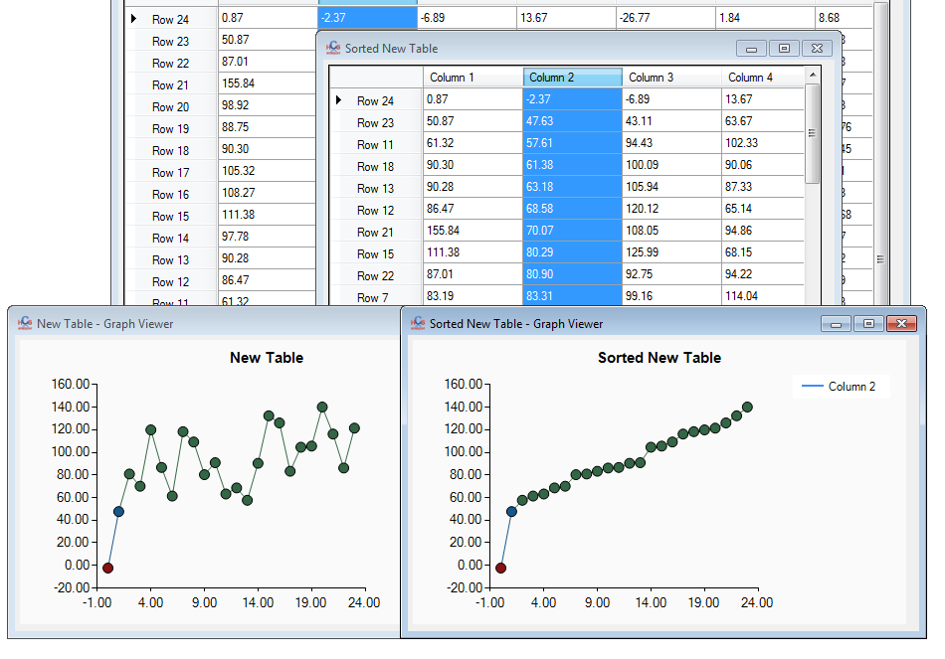

As usual, the data points continue to contains links to the original data, and thus allow the user to access information about them, even after manipulations:

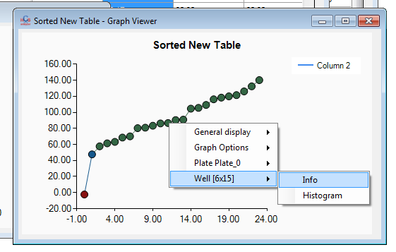

Let’s go back to newly developed components: histogram and stacked histograms. Stacked histogram has been used in the user interface like here:

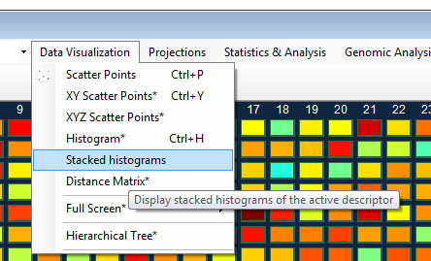

After selecting the classes you want display,

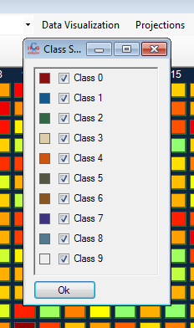

And regarding the process mode you selected (Current plate, plate by plate, entire screening), here are the results:

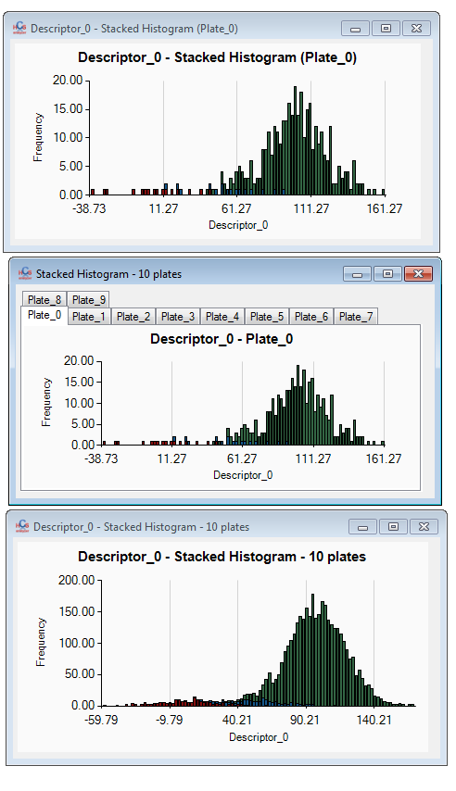

As the component is deriving from a regular display component, you’ll have access to the regular options, but also to specific ones, like the bin number:

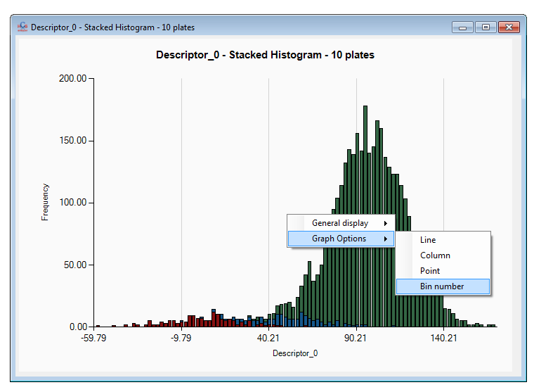

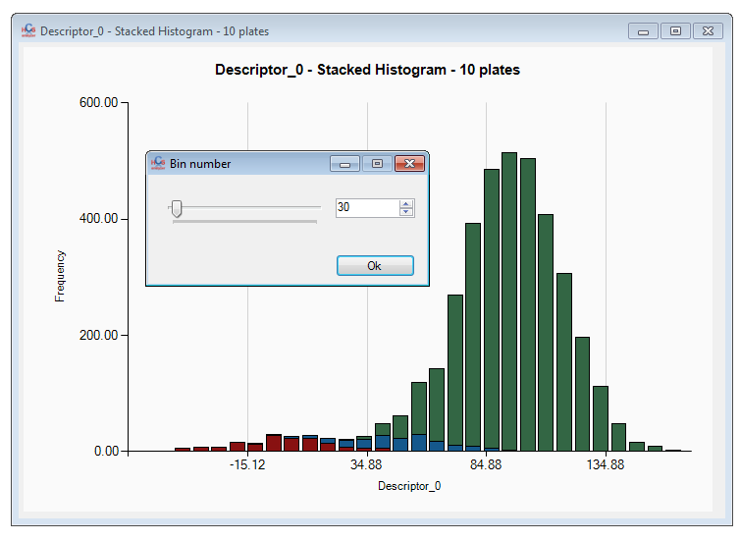

In this case, you can also access class related options by clicking on one of them:

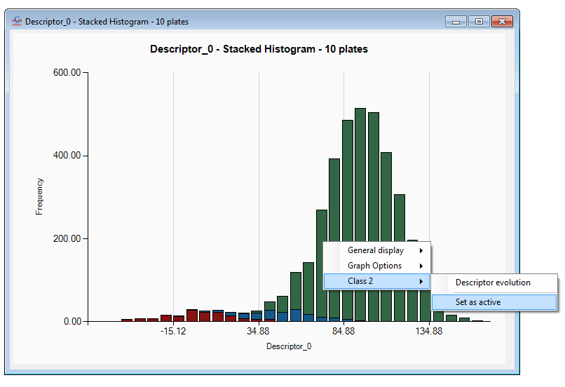

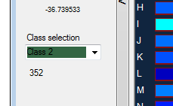

Many others are in progress to make your work easier. Now let’s take a look at the projection menu.

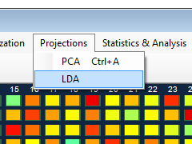

If you click on LDA, you’ll have to choose all the classes that you want discriminate:

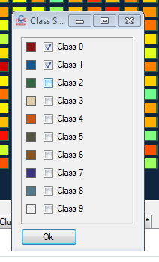

After processing, you’ll have access to the entire LDA basis:

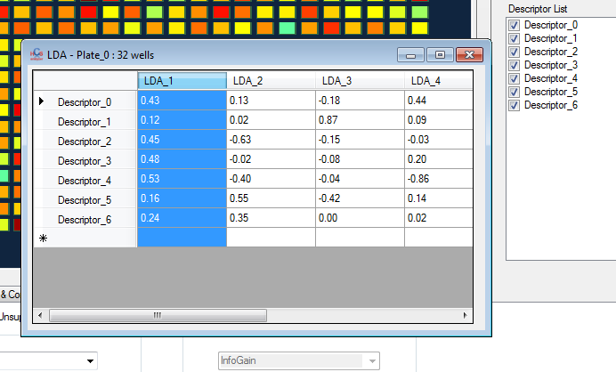

If you want generate a LDA axis, just right click on one of column header, and select “perform projection”:

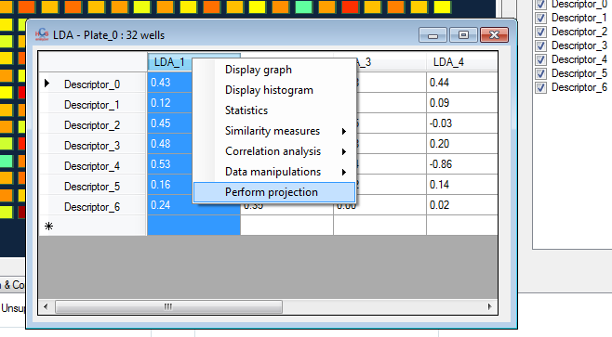

Here, I’ve done it on LDA_1 and LDA_2 and here is the result:

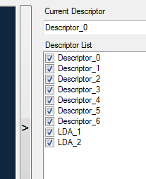

Information about the projection is accessible through the descriptor info:

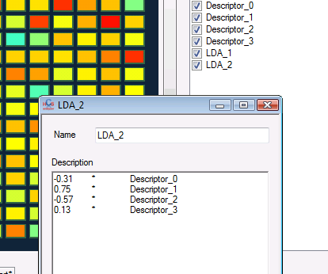

Finally, one can visualize the results using the new 2D scatter points:

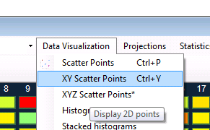

Let’s briefly talk about this new viewer. First, select the classes you want to be taken into account for the display:

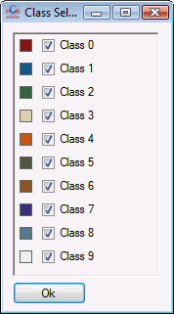

You can change the axis by using the context menu Graph Options-> X-Axis or Y-Axis

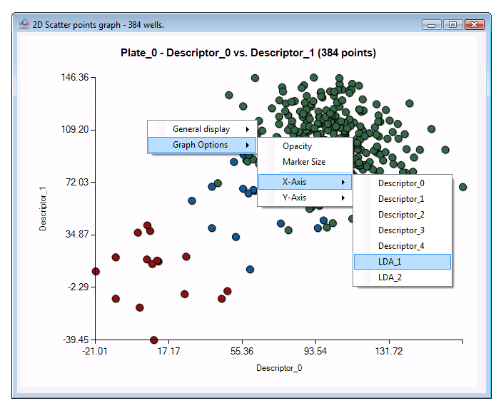

Similarly to the 1D scatter point graph, you can select points, and, if they are defined as “wells” and change their classes. You can notice a new feature available through the selection associated context menu: Get associated data table.

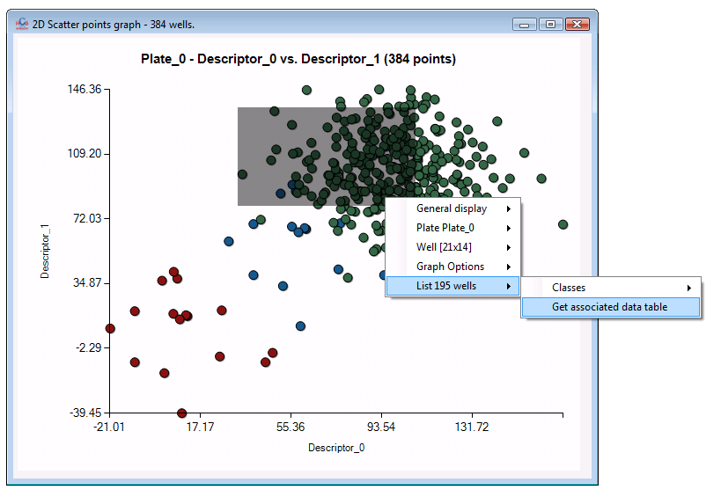

By clicking on it, you’ll display a table containing the active descriptor values as well as the class associated to each selected points.

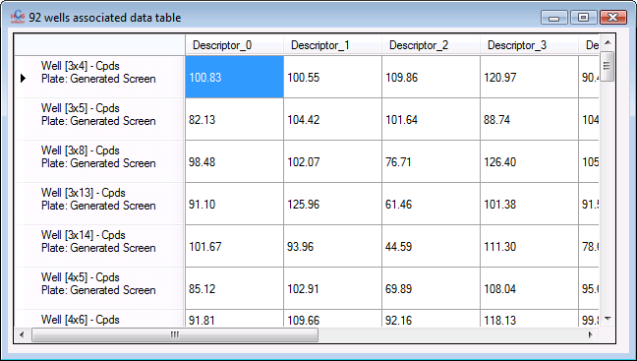

You can then perform as usual any kind of data analysis, or display information about descriptors.

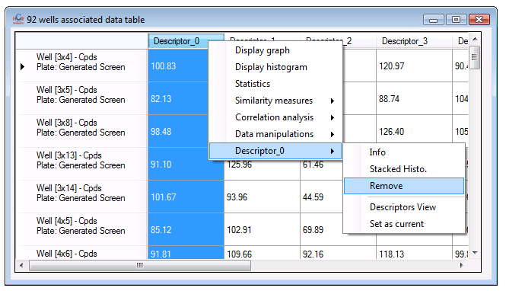

Same things can be done with the PCA projection.

Let’s move to Statistics & Analysis -> Quality controls -> Z-score

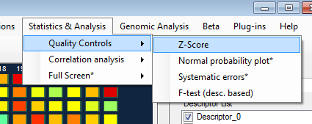

You can now select whatever class you want compare:

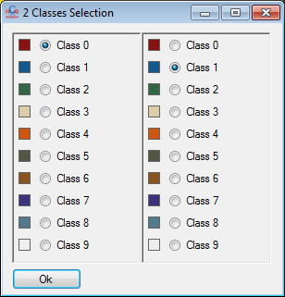

(There is no more limitation to neg/pos controls). Depending of the selected process mode, different displays will popup:

[Current plate only] displays ranked Z-factor for all the descriptors.

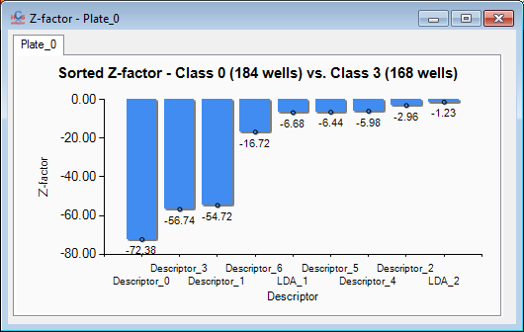

Same thing for [plate by plate], for each plate individually:

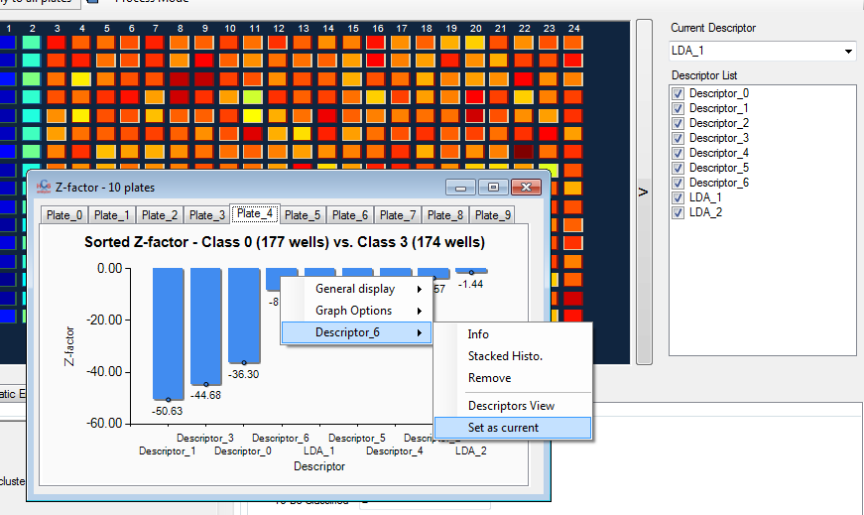

By the way, by clicking on a Z-score you can access the selected descriptor associated context menu.  
You can by example select one of them as current descriptor:

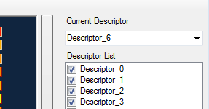

Finally in [entire screening] mode, you’ll see the selected descriptor Z-score evolution within the screening:

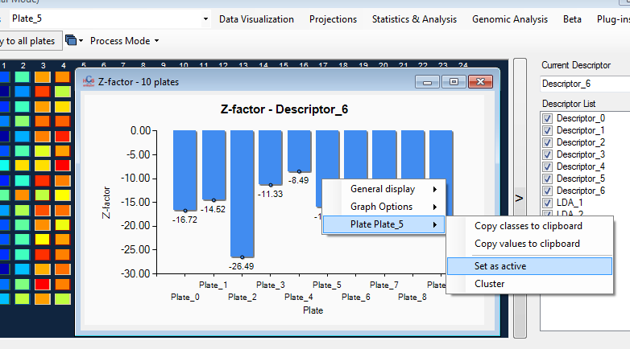

To conclude this update, I also added a new histogram display linked to every well object. By example if you click on:

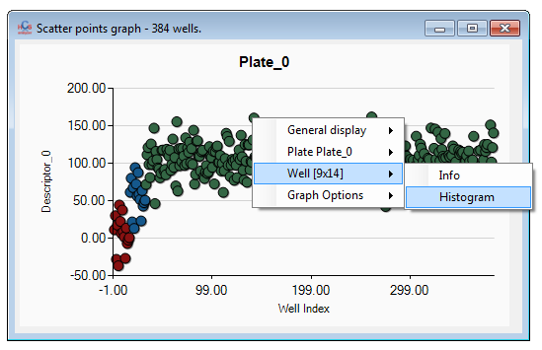

You will access this window:

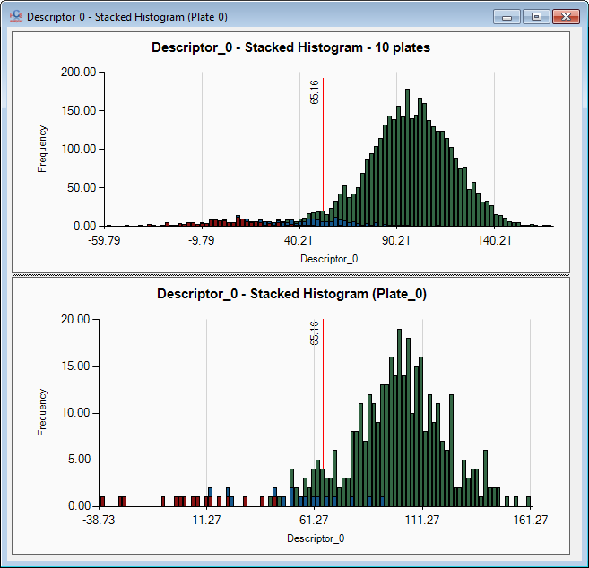

Displaying histogram of the current selected descriptor: the top one is for the entire screening and the bottom one for the current plate only. A vertical red line highlights the position of the selected well within each histogram.

Now it is time for me to move the single cell analysis to the new core to make everything consistent. In parallel, I am constantly adding statistical features and visualization tools to the software. The software finally goes into the direction I was thinking about.